# System Overview

### Behavioral Stage

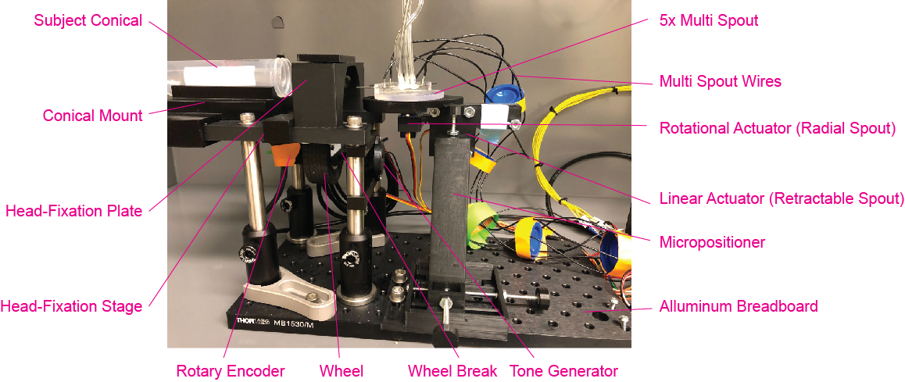

### Behavioral Box Internal

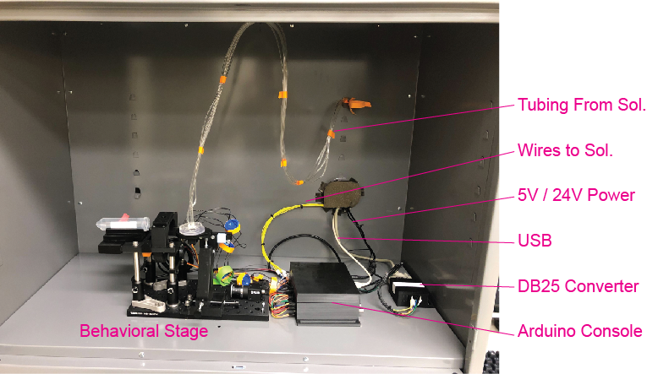

### Behavioral Box External

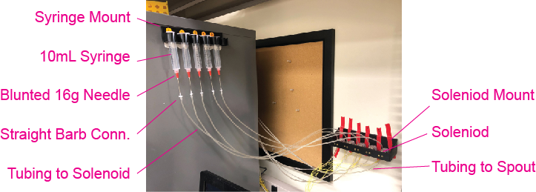

# Hardware

This section consists of descriptions of the main components of the head-fixed system and is broken into two sub sections: 1) 3d printed components 2) Electrical components. This section should serve as a reference to help with identifying components and their relations to one another. The electrical component section will also serve as a quick guide to proper wiring.

## 3d Printed Components

This sub section contains all the 3d printed components used for the behavioral system. Unless otherwise noted, each piece can be printed using filament. Each section includes images from one or more of the following open-source Tinkercad files:

* Assembly ([link](https://www.tinkercad.com/things/58vTdDu0pfz-headfixedsystemassembly))
* Components Filament ([link](https://www.tinkercad.com/things/1Yv3k1L5hwq-headfixedsystemcompoenentsfilament))
* Components Resin ([link](https://www.tinkercad.com/things/6Ztq3dLU4Uj-headfixedsystemcomponentsresin))
* Components Multi Spout ([link](https://www.tinkercad.com/things/cckeigB3ydE-headfixedsystemcomponentsmultispout))

### Head-Fixation

Assembly Components Filament

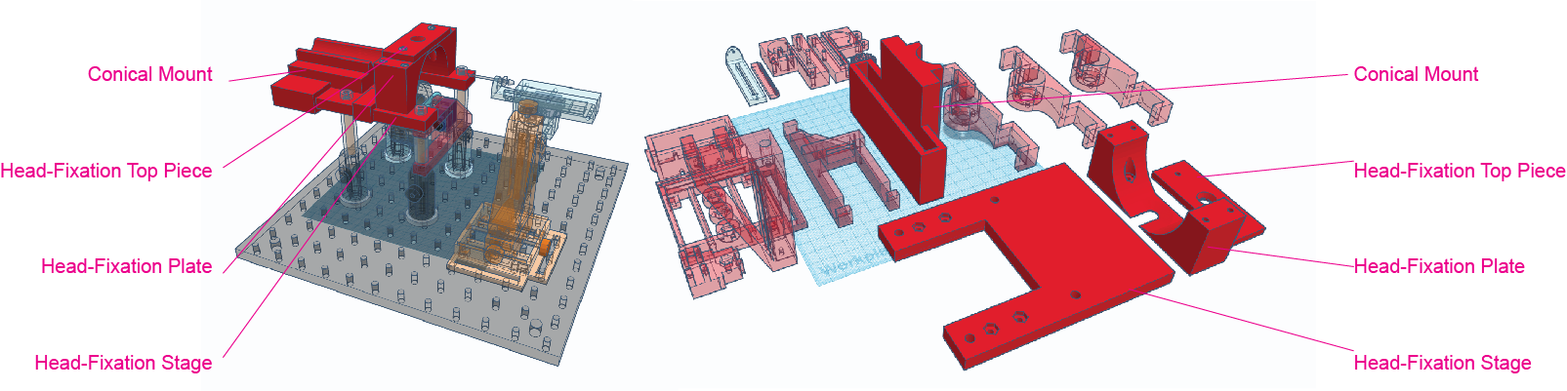

Purpose:

* To stably mount subjects with head-ring implantations.

Components:

* Head-Fixation Stage: Stage that is fixed to optical posts that mounts on additional components
* Head-Fixation Plate: Horizontal plate that the subject’s head-ring is slotted on top of
  + NOTE: We advise having back-ups of this component because with extensive use this piece can be worn down to the point that the head-rings slide through the plate.
* Head-Fixation Top Piece: Cap that is tightened downward to hold subject’s head-ring in place
  + NOTE: Other versions of this top pieces exist for particular applications (e.g. accommodating the Inscopix baseplate).
* Conical Mount: Removable adapter for mounting subject conical. This component can be swapped out for different applications (larger subjects, tail fixation, etc.)

### Wheel/Rotary Encoder Mount

Assembly Assembly Expanded

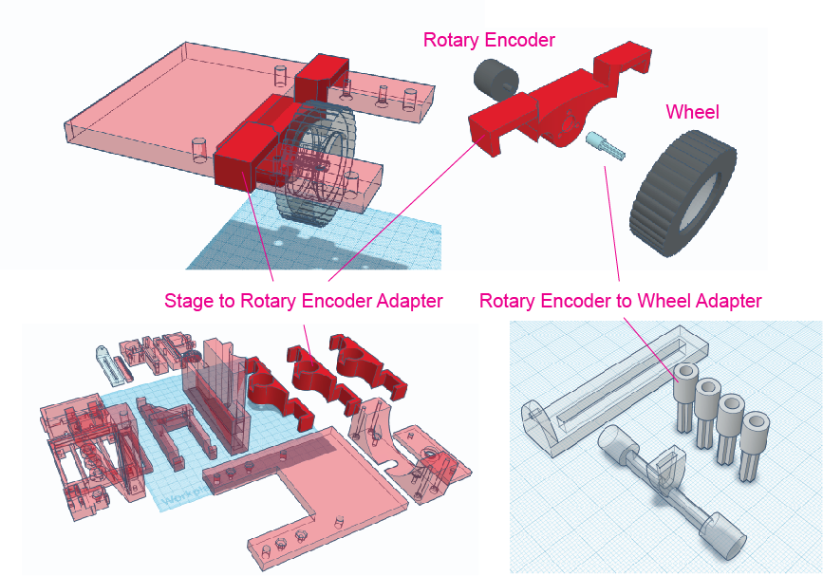

Filament Components Resin Components

Purpose:

* To mount the rotary encoder and wheel directly beneath the head-fixation stage

Components:

* Stage to Rotary Encoder Adapter
  + Options: 3 different heights are included for different approaches (subjects with different sizes or head-rings of different heights). Default is the mid-height option.
* Rotary Encoder to Wheel Adapter (*resin*)
  + 3d model includes multiple replications of the pieces with slightly different inner diameters. The component should fit very snugly on the rotary encoder and small imperfections from different prints can result in different inner diameters fitting best.
* Wheel: Lego Wheel 43.2mm D. x 18mm - Flush Axle Stem with Black Tire 62.4 x 20 S (86652 / 32019) (see [www.bricklink.com/](http://www.bricklink.com/))
* Rotary Encoder (see *Electrical Components- Rotary Encoder*)

### Wheel Break

Assembly Assembly Expanded

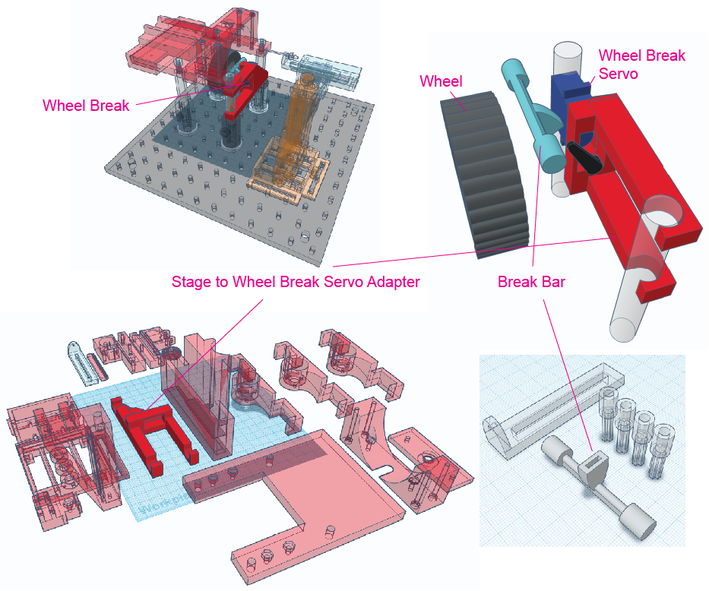

Filament Components Resin Components

Purpose:

* The wheel break is used to prevent wheel rotation thereby limiting free access to operant responding.

Components:

* Stage to Wheel Break Servo Adapter
* Wheel Break Servo (see *Electrical Components- Servos*)
* Break Bar (*resin*)

### Micro positioner

The micro positioner design is adapted from Backyard Brains (https://backyardbrains.com/products/micromanipulator).

Assembly Assembly Exploded

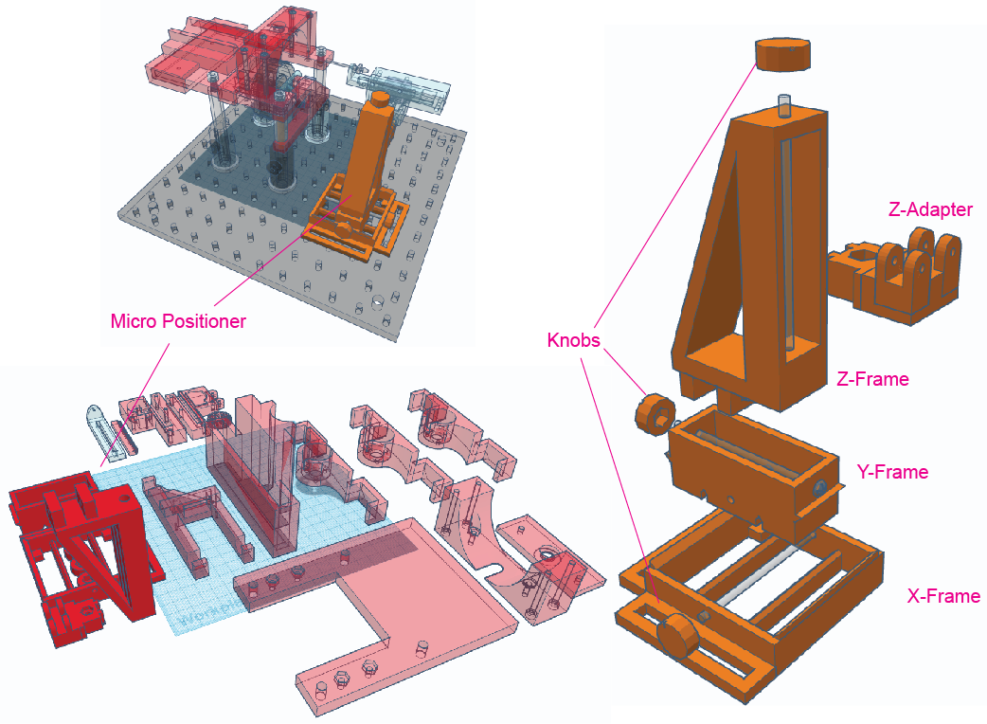

Components Filament

Purpose:

* The micro positioner is used to position the spout directly in front of the subject.

Components:

* X-Frame
* Y-Frame
* Z-Frame
* Z-Adapter: connects micro positioner to linear actuator
* 3x Knob

### Linear Actuator for Retractable Spout (Single Spout)

The linear actuator design is adapted from https://hackaday.io/project/10578-3d-printed-linear-servo-extender.

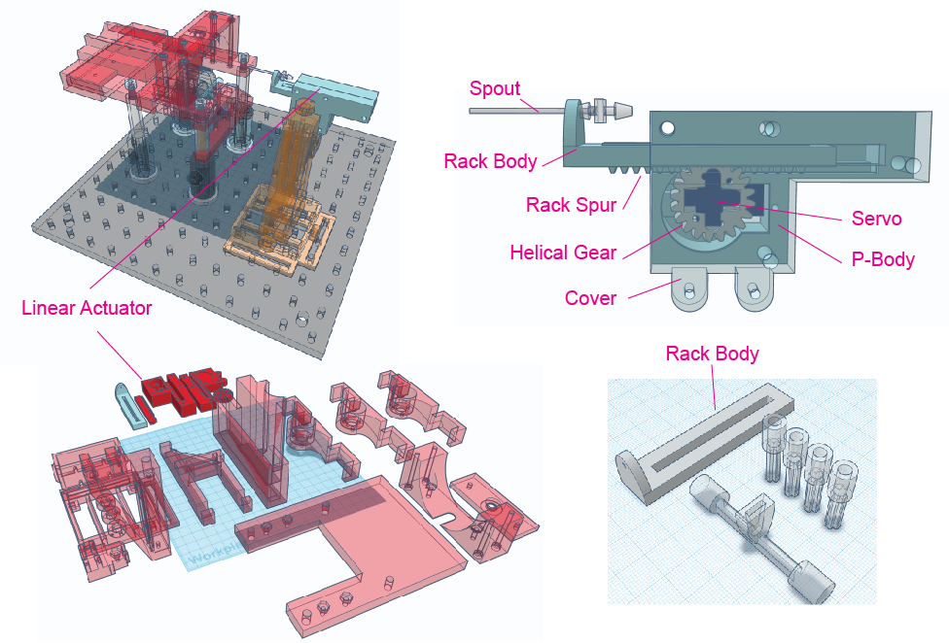 Assembly Assembly Enlarged

Filament Components Resin Components

Purpose:

* The linear actuator allows the spout to be retracted and extended thereby regulating access to consumption.

Components:

* Spout (see below for building instructions)
* Rack Body (*filament or resin*): Mounts the spout and seats the rack spur which allows the rack body to travel forward and backward.
  + The rack body can be made of filament or resin. Resin produces the best fit for the spout, but with the right settings a filament pieces can work as well.
* Rack Spur: Rests inside rack body and interfaces with the helical gear and transfers rotation of helical gear to linear travel
* Helical Gear: Transfers servo rotation to movement of rack spur
* P-Body: Mounts servo and holds helical gear, rack body, and rack spur in alignment
* Cover (transparent in image): Works with P-Body to hold components in alignment and interfaces with Z-Adapter of the micro positioner
* Servo (see *Electrical Components- Servos*)

### Linear Actuator & Radial Actuator for Multi-Spout

Components of the Multi-Spout

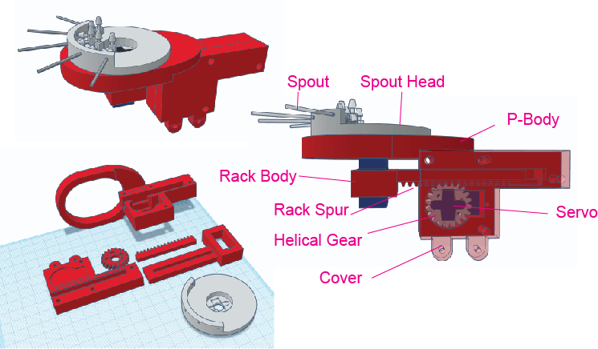

Purpose:

* The linear actuator allows the spout to be retracted and extended thereby regulating access to consumption. The radial actuator allows the spout head to be rotated to allow access to 1 of multiple spouts.

Components:

* Spout (see below for building instructions)
* Rack Body: Mounts the servo for radial travel and seats the rack spur which allows the rack body to travel forward and backward
* Rack Spur: Rests inside rack body and interfaces with the helical gear and transfers rotation of helical gear to linear travel
* Helical Gear: Transfers servo rotation to movement of rack spur
* P-Body: Mounts servo and holds helical gear, rack body, and rack spur in alignment
  + NOTE: The multi-spout P-Body also has a support for the spout head
* Cover (transparent in image): Works with P-Body to hold components in alignment and interfaces with Z-Adapter of the micro positioner
* Spout Head: Mounts multiple spouts angled relative to the center of the spout head
* Servo for linear travel (see *Electrical Components- Servos*)
* Servo for radial travel (see *Electrical Components- Servos*)

### Most-in-One (optional)

This 3d model consists of the Head-Fixation, Wheel/Rotary Mount, and mounting posts as a single piece.

Head-Fixed System Most-in-One Filament

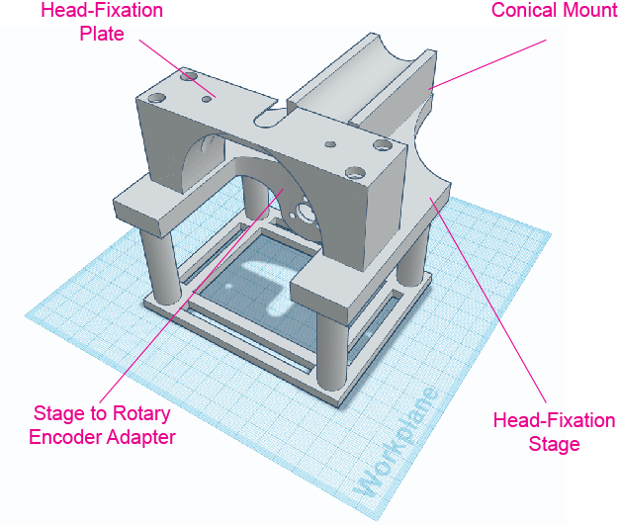

The advantage of this model is that it reduces the cost of the system by replacing the need for optical posts, post mounts, and clamping forks. The disadvantage of the model is that it does not have adjustable height and is not modular. Users can decide if the most-in-one version of the stage is the best approach by weighing these two sets of factors.

## Electrical Components

### Micro Processor

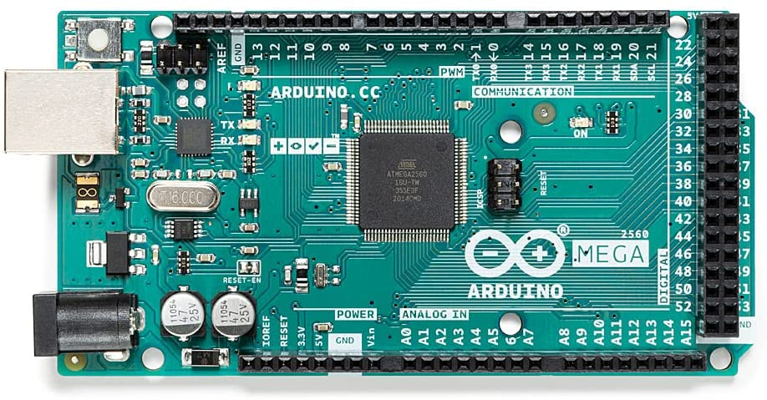

Purpose:

* To control behavioral hardware and to record behavioral events.

Components:

* [Arduino Mega 2560 Rev 3](https://www.amazon.com/ARDUINO-MEGA-2560-REV3-A000067/dp/B0046AMGW0/ref=asc_df_B0046AMGW0/?tag=hyprod-20&linkCode=df0&hvadid=309743296044&hvpos=&hvnetw=g&hvrand=13165927428354662590&hvpone=&hvptwo=&hvqmt=&hvdev=c&hvdvcmdl=&hvlocint=&hvlocphy=9033316&hvtargid=pla-516265455074&psc=1)
  + NOTE: Other Arduinos can be used in place of this model. However, the capacitive touch sensor has associated libraries that may not be compatible with all Arduinos.

### Capacitive Touch Sensor

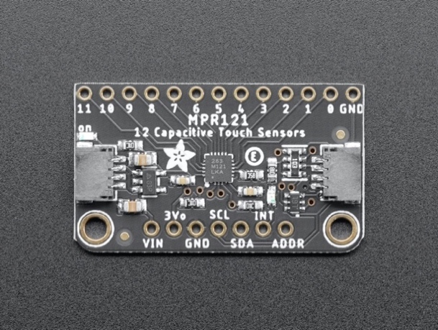

DIAGRAM SHOWING CONNECTIONS

Purpose:

* The capacitive touch sensor is used to detect licks on each lick spout.

Components:

* [Adafruit MPR121](https://learn.adafruit.com/adafruit-mpr121-12-key-capacitive-touch-sensor-breakout-tutorial)

Connections:

* VIN 5V input
* GND Ground
* SDA SDA on Arduino MEGA pin 20
* SCL SCL on Arduino MEGA pin 21
* 1-n Spout(s) 1-n

**Solenoid and Solenoid Circuit**

Purpose:

* The solenoid circuit allows the Arduino output pins with a 5V gate 24V to open the solenoid.

Components:

* Solenoid ([Parker Series 3 – Miniature Inert Liquid Vlave 003-0257-900](https://ph.parker.com/us/12051/en/series-3-miniature-inert-liquid-valve/003-0257-900))
* Transistor (Tip 120)
* Resistor (5.6kohm)
* 24V power supply
* Wires to connect to common ground and Arduino

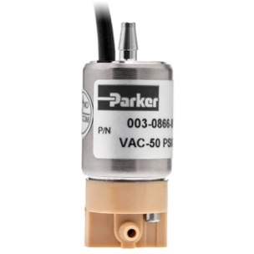

DIAGRAM OF CIRCUIT

### Servos

Purpose:

* Each servo controls components of the system. The absolute rotational position of each servo can be set independently using unique Arduino pins. There are up to 3 servos depending on the type of system.
  + Wheel break
  + Linear actuator for retractable spout
  + Radial actuator for multi-spout

Components:

* [Tower Pro SG92R](https://www.adafruit.com/product/169)

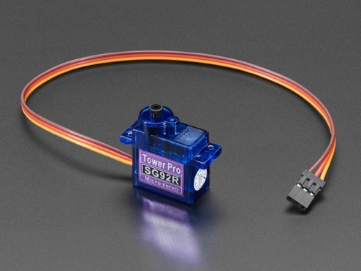

Connections:

* 5V Power (Orange) 5V input
* Ground (Brown) Common ground
* Signal (Yellow) Arduino pin

### Rotary Encoder

Purpose:

* The rotary encoder measures rotation. The rotary encoder used in this system is an optical, incremental rotary encoder that measures relative rotation, not to be confused with an absolute rotary encoder that measures the absolute rotational position of the encoder.

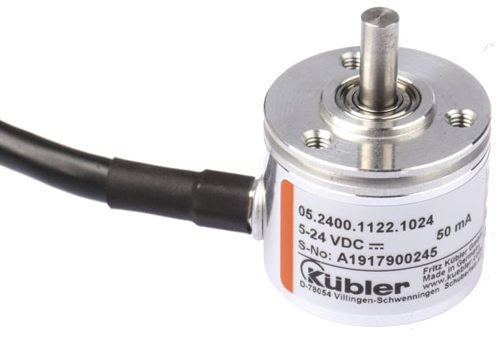 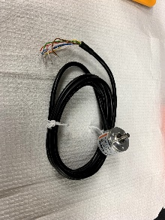

Components:

* [Kubler Incremental Encoder 1024 ppr, 05.2400.1122.1024](https://export.rsdelivers.com/product/kubler/05240011221024/kubler-incremental-encoder-1024-ppr-05240011221024/4314599)

Connections:

* Rotary encoder A (Grey) Arduino pin
* Rotary encoder B (Green) Arduino pin
* Ground (Brown) Common ground
* 5V Power (White) 5V power supply
* NOTE:

The Arduino script reading the rotary encoder relies on interrupt service routines (ISR) which are only possible on [specific Arduino pins](https://www.arduino.cc/reference/en/language/functions/external-interrupts/attachinterrupt/). It is critical that the rotary encoder A and B are attached to these specific pins. Our scripts are written to have rotary encoder A on pin 2 and B on pin 3.

# Assembly Instructions

In this section, we will first assemble the following subcomponents:

1. Micro positioner
2. Lick spouts (single & multi)
3. Linear actuator (single spout)
4. Linear actuator & radial actuator (multi spout)
5. Rotary encoder
6. Tone generator
7. Preparation of external electrical components
8. Arduino circuit

Then, we will assemble subcomponents into the final system

1. Stage assembly
2. Connecting electrical components
3. Liquid delivery

See the *Hardware* section for a detailed guide to each of the 3d models and electrical components that will be used in this section.

## *Assembly of Subcomponents*

### Micro positioner

Components and building materials:

* 3d printed components
  + X-Frame
  + Y-Frame
  + Z-Frame
  + Z-Adapter: Connects micro positioner to linear actuator
  + 3x Knob
* Other components
  + 3x machine screws
  + 6x hex nuts
* Tools and Materials
  + Vice clamp
  + Screwdriver
  + Super glue
  + JB weld epoxy (optional)
  + Magnets 3/16” (optional)

Follow the building instructions provided [here](https://osf.io/zxbtv)with the following modifications:

* The angled Z-Frame in the original design has been replaced with a perpendicular one.
* the Z-Adapter has been replaced with one that allows for a more secure grip to the retractable spout frame.
* The X-Frame has been modified to include a rail to assist with mounting to a breadboard.

OPTIONS: If you are using a metal plate or the floor of your behavioral box as a stage instead of an aluminum breadboard, follow the steps in the instructions for attaching magnets under the micro positioner.

* These magnets will be sufficient for fixing the micro positioner in place but will not be as robust as fixing to an aluminum breadboard.

TROUBLE SHOOTING:

* If the nuts disconnect from the machine screws during operation, then use JB weld in place of super glue for greater security.
* If the hex nuts do not fit into the knobs, use a vice clamp to force them in place.

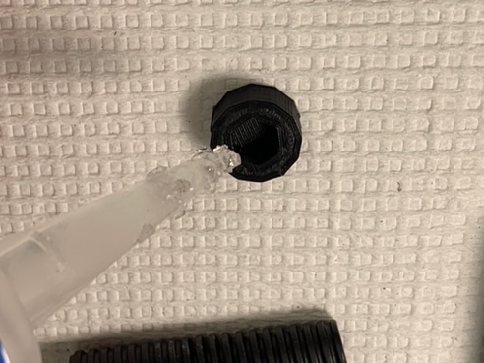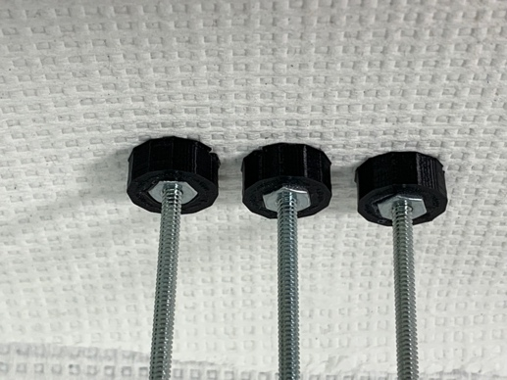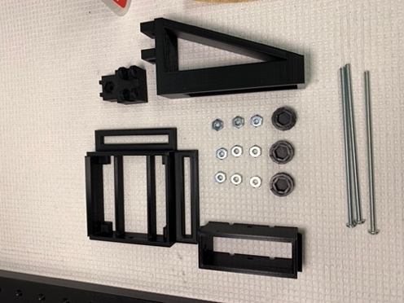

Components for the micro positioner

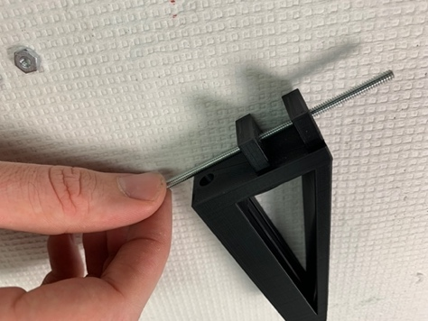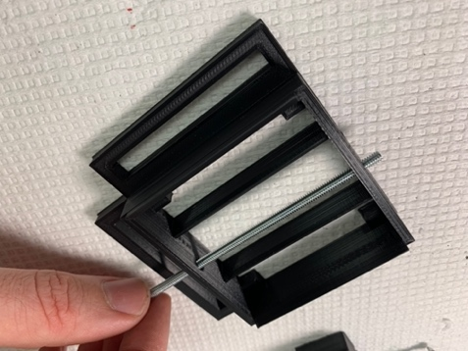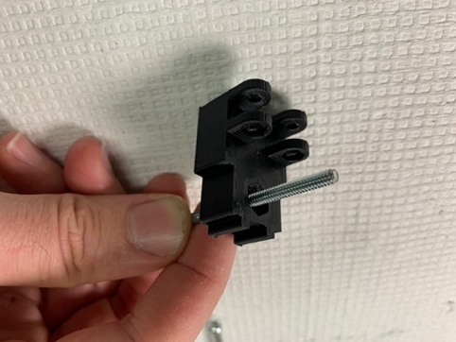

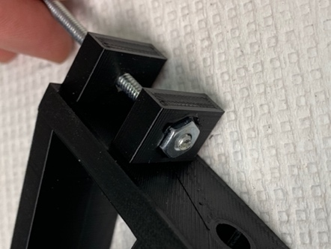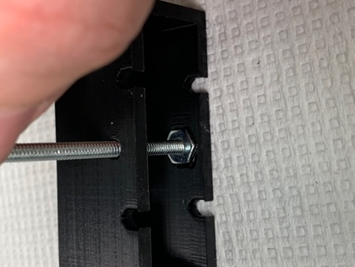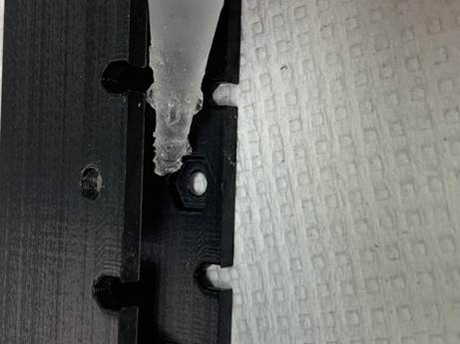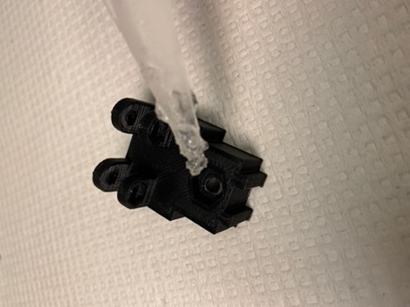

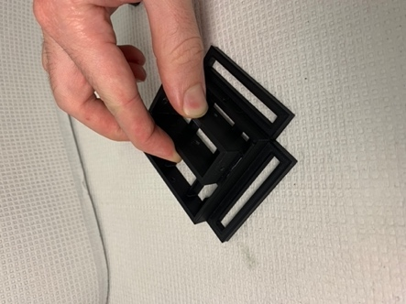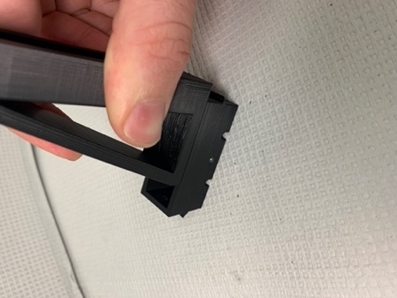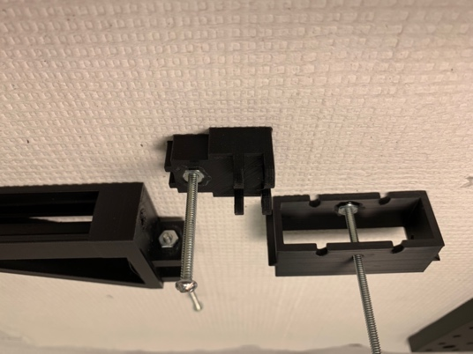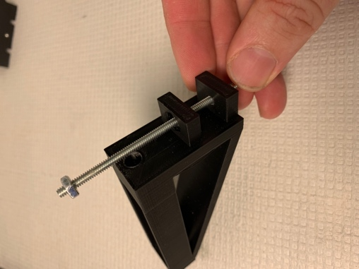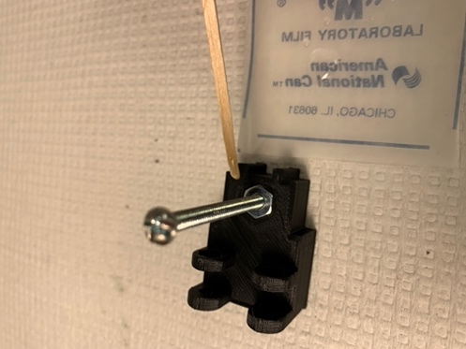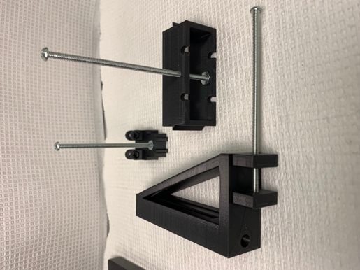

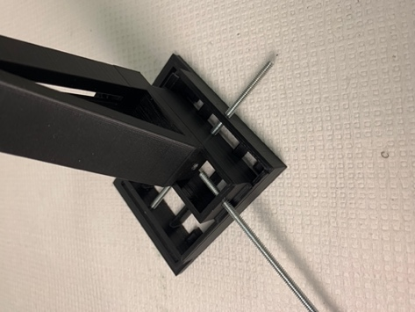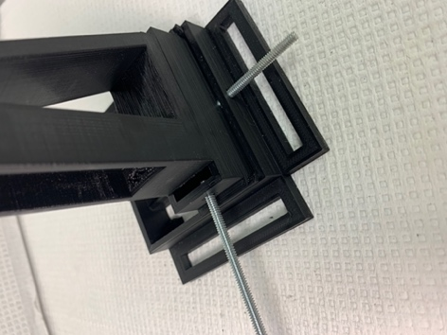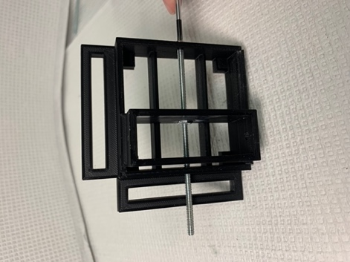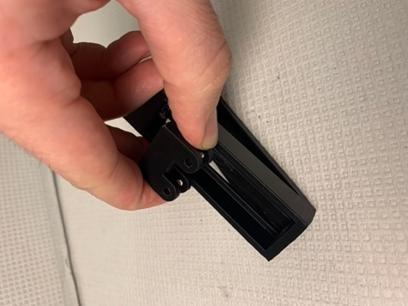

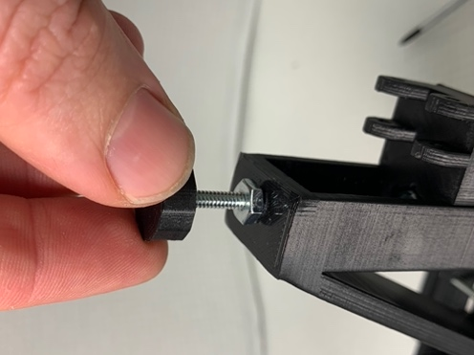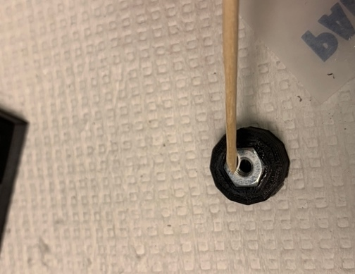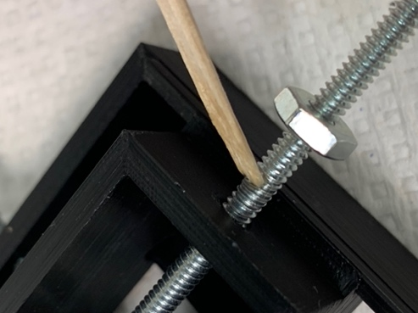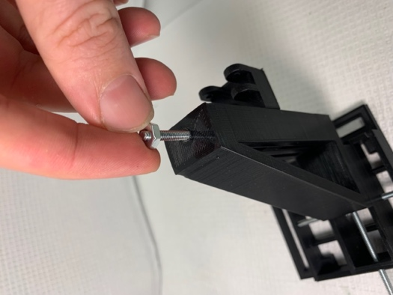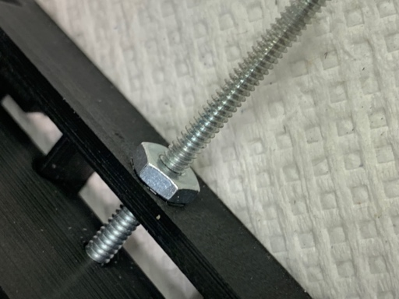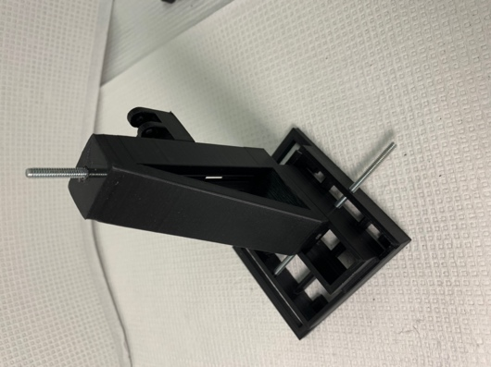

### Lick spouts

Components and building materials:

* Protective eyewear
* 16g needle (1 needle per spout)
* Vice clamp or dremel press mount
* Dremel
* Cutting disk for dremel
* Plyers (or hemostat)

Instructions:

1. PUT ON PROTECTIVE EYEWEAR!
2. Mount the dremel in the vice clamp or dremel press mount.
3. Cut the 16g needle or hypodermic tubing
   1. Using a pair of plyers, hold the needle near the hilt leaving a small piece of metal exposed before the hub of the needle.
   2. Turn the dremel on high.
   3. Carefully press the exposed portion of the needle down onto the cutting disk until you can cut the needle in two.
4. Smooth both ends of the needle
   1. Using a pair of plyers, hold the needle and gently press the bevel into the face of the cutting disc until you have completely sanded down the bevel. You should now have a dulled piece of tubing.
   2. Using your hands, hold the dulled tubing at an angle relative to the cutting disc. Gently press the tubing against the cutting disc and slowly rotate the tubing as you increase the angle to reach perpendicular with the sanding disk.
   3. Use your finger to feel how smooth the edges of the tubing are. If the tubing still has rough edges that snag on your skin or gloves, repeat the previous step until the edges are completely smooth.
   4. Repeat the previous 2 steps with the other side of the tubing.

### Multi-spout head

Components and building materials:

* 3d printed components
  + Spout head
  + Spout head assembly guide
* Prepared components
  + 5x spout (see above)
* Tools and materials
  + Vice clamp
  + Dremel with cutting disc
  + 5x wire (~ 15cm)
  + 5x female jumper cables
  + Small diameter heat shrink tubing
  + Wire stripper
  + Helping hands
  + Soldering iron
  + Solder
  + 5x angled barb connector
  + Super glue

Instructions:

1. Connect each wire to a female jumper cable connector
   1. Cut a jumper cable with a female lead.
   2. Strip the jumper cable and wire leaving ~10mm of wire exposed.
   3. Solder the two exposed pieces of wire together and check for a stable connection (pull on both and ensure structural integrity).
   4. Cover the exposed piece of wire with heat shrink tubing.
2. Solder each spout to a wire
   1. Mount the dremel with cutting disc to vice clamp and turn on.
   2. Score the circumference of the spout ~15mm from one end of the spout by gently pressing the spout to the cutting disc and rotating the spout with your hands.
   3. Strip the remaining end of the wire attached to the female jumper connector using the wire stripper with ~20mm of wire exposed.
   4. Wrap the braids of the wire around the cored portion of the spout as tightly as possible.
   5. Mount the spout/wire to the helping hands.
   6. Use the soldering iron to heat up the spout/wire for an extended period and then encase the wire/spout junction with solder.
   7. Allow the solder to cool completely and then check the strength of the connection by attempting to rotate the wire forcefully. If the wire can rotate, repeat the previous step until the connection is secure.
3. Press the angled barb connector onto the spout on the end closest to the wire and rotate so the opposite barb is parallel to the wire.
4. Fix the spouts in position
   1. Partially insert each spout through the holes in the spout head.
   2. Set the spout head in the center of the spout head assembly guide.
   3. Press the spout until it slots into the spout inset of the head assembly guide.
   4. Rotate the wires so they are all extended upward.
   5. Apply super glue to the junction between each spout and the hole.
   6. Allow the assembly to cure overnight.

* NOTE: If you do not use the spout head assembly guide, make sure that each spout extends out of the spout head to the same length and that each spout is tilted to the same height. Differences in length can be corrected using the linear actuator, differences in height cannot be corrected for.

### Linear actuator (single spout)

Components and building materials:

* 3d printed components
  + Rack body
  + Rack spur
  + Helical gear
  + P-Body
  + Cover
* Electrical components
  + 1x Servo
* Assembled component
  + Spout
* Tools and Materials
  + Philips screwdriver
  + Razor blade
  + 4x machine screws
  + 4x hex nuts
  + Screws for servo (2x large, 1x small, should be included with servo)
  + 4 arm horn for servo (should be included with servo)
  + Machine oil
  + Vice clamp
  + Dremel with cutting disc
  + Straight barb connector

Instructions:

1. Secure the servo to the P-Body using the 2 large screws that came with the servo. Make sure that the servo is oriented with the output shaft of the servo centered in the circular cut out of the P-Body.
2. Score the horn by pressing the sharp edge of a razor at the second circular hole into the arm perpendicular to the arm. Next, hold the horn and forcefully bend the arm to snap the horn at the scored position.
3. Seat the horn in the helical gear with the extension of the horn facing away from the opening of the helical gear. If the horn does not fit, repeat the previous step to make the horn shorter.
4. Attach the horn/helical gear to the output shaft of the servo by forcefully pinching the horn to the servo with your fingers and then screwing into place using the small screw that came with the servo.
5. Insert the rack spur into the rack body with the spout mount and the spurs facing in opposite directions.
6. Liberally lubricate the rack spur, helical gear, P-Body, and cover with machine oil.
7. Rotate the gear **CLOCKWISE** as far as possible.
8. Insert the rack spur/rack body into the P-Body with the rear rack body as close to the back of the P-Body as possible. The teeth of the rack spur should thread between the teeth of the helical gear.
9. Place the cover onto the P-Body.
10. Cut machine screws to be long enough to fit through the P-Body/cover and still attach a hex nut (~30mm).
    1. Mark the intended length on the machine screw using a felt tipped pen
    2. Mount the machine screw in the vice clamp on the terminal end of the screw leaving the length marker exposed.
    3. Use the dremel to cut the machine screw. The screw will become very hot, so use forceps or another tool to handle.
    4. Screw a hex nut onto the machine screw multiple times to ensure that the threads of the machine screw have not been damaged.
11. Insert machine screws through the screw holes in the P-Body/cover and screw hex nuts onto the extended portion of the machine screws.
12. Insert a spout into a straight barb connector forcefully until secure. Then insert the spout/straight barb connector into the spout hole of the front side of the rack body.

### Linear actuator & radial actuator (multi-spout)

Components and building materials:

* 3d printed components
  + Rack body
  + Rack spur
  + Helical gear
  + P-Body
  + Cover with spout head support
* Electrical components
  + 2x Servos
* Assembled components
  + Spout head with multi-spouts (see above)
* Tools and Materials
  + Philips screwdriver
  + Razor blade
  + 4x machine screws
  + 4x hex nuts
  + Screws for servo (4x large, 2x small, should be included with servo)
  + 2x 4 arm horn for servo (should be included with servo)
  + Machine oil
  + Vice clamp
  + Dremel with cutting disc

Instructions:

1. Secure the first servo to the P-Body using the 2 large screws that came with the servo. Make sure that the servo is oriented with the output shaft of the servo centered in the circular cut out of the P-Body.
2. Secure the second servo to the rack body using the 2 large screws that came with the servo. Make sure that the servo is oriented with the output shaft of the servo centered with the parallel arms of the rack mount.
3. Score the horn by pressing the sharp edge of a razor at the second circular hole into the arm perpendicular to the arm. Next, hold the horn and forcefully bend the arm to snap the horn at the scored position. Repeat for the second horn.
4. Seat one of the horns in the helical gear with the extension of the horn facing away from the opening of the helical gear. If the horn does not fit, repeat the previous step to make the horn shorter.
5. Attach the horn/helical gear to the output shaft of the servo by forcefully pinching the horn to the servo with your fingers and then screwing into place using the small screw that came with the servo.
6. Insert the rack spur into the rack body with the spout mount and the spurs facing in opposite directions.
7. Liberally lubricate the rack spur, helical gear, P-Body, and cover with machine oil.
8. Rotate the gear **COUNTERCLOCKWISE** as far as possible.
9. Insert the rack spur/rack body into the P-Body with the front rack body as close to the inside edge of the spout head as possible. The teeth of the rack spur should thread between the teeth of the helical gear.
10. Place the cover onto the P-Body.
11. Cut machine screws to be long enough to fit through the P-Body/cover and still attach a hex nut (~30mm).
    1. Mark the intended length on the machine screw using a felt tipped pen
    2. Mount the machine screw in the vice clamp on the terminal end of the screw leaving the length marker exposed.
    3. Use the dremel to cut the machine screw. The screw will become very hot, so use forceps or another tool to handle.
    4. Screw a hex nut onto the machine screw multiple times to ensure that the threads of the machine screw have not been damaged.
12. Insert machine screws through the screw holes in the P-Body/cover and screw hex nuts onto the extended portion of the machine screws.
13. Rotate the servo mounted in the Rack Body **CLOCKWISE** as far as possible.
14. 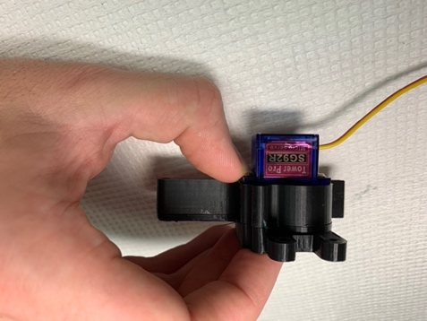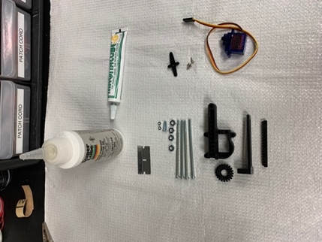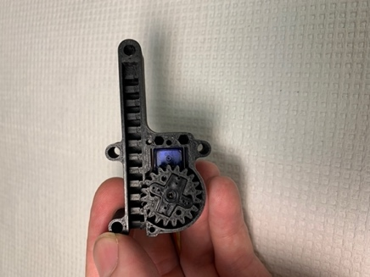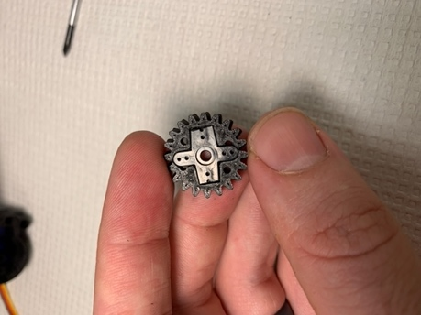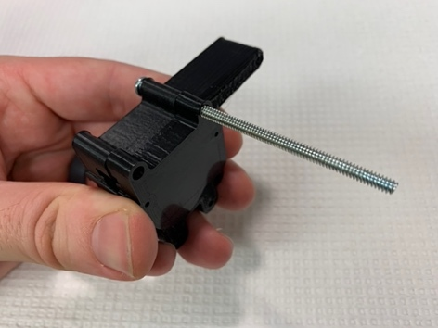 Seat the second horn in the spout head assembly with the left spout as close to slightly clockwise of the axis of travel. Next fix the horn to the servo by forcefully pinching the horn to the servo with your fingers and then screwing into place using the small screw that came with the servo.

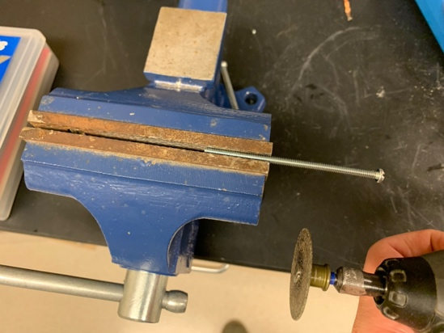

Use the dremel to cut the machine screw

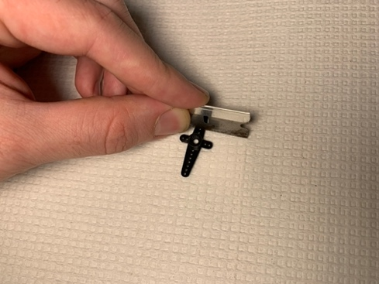

Score the horn with a razor

Helical gear

P-Body

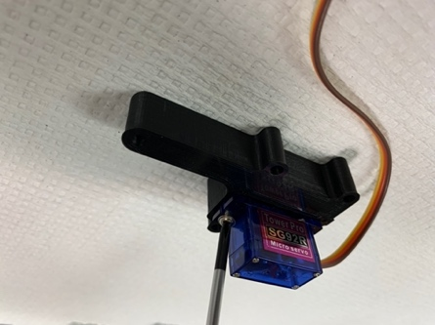

Secure servo to P-Body

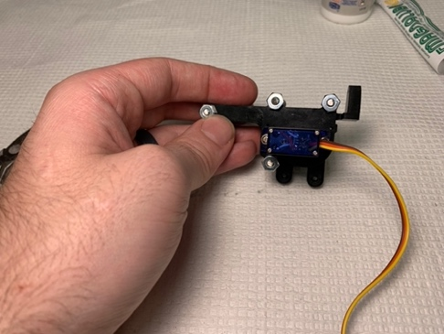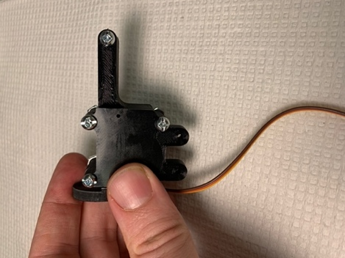

Finished product (back)

Finished product (front)

### Wheel Break

Components and building materials:

* Electrical component
  + Stage to Wheel Break Servo Adapter
  + Break Bar
* Tools and Materials
  + Servo
  + Screws for servo (2x large, 1x small, should be included with servo)
  + 1 arm horn for servo (should be included with servo)

Instructions:

1. Secure the servo to the Stage to the Wheel Break Servo Adapter using the 2 large screws that came with the servo. Make sure that the servo is oriented with the output shaft of the servo located on the bottom of the adapter (single arm of the adapter is located on the bottom).
2. Rotate the servo **COUNTERCLOCKWISE** as far as possible.
3. Seat the horn to the servo such that it is at a roughly 45-degree angle and press into place by pinching with your fingers and then screwing into place using the small screw that came with the servo.
4. Place the break bar onto the extension of the horn using moderate force.

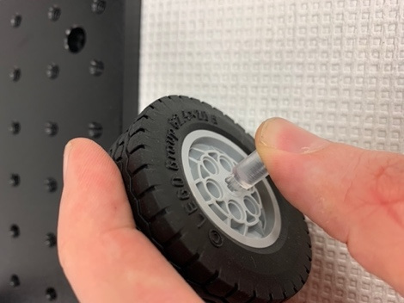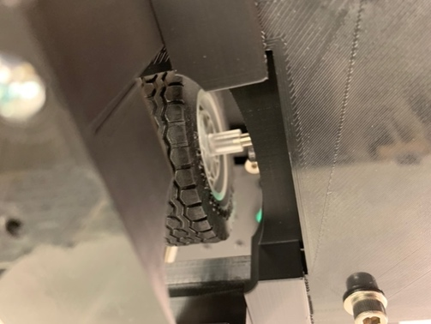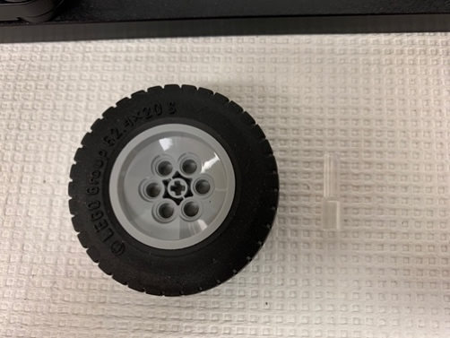

### Head-Fixation Plate or Most-in-One

Components and building materials:

* 3d printed components
  + Head-fixation plate
* Tools and materials
  + 2x hex nut
  + Machine screw
  + JB weld epoxy
  + Wooden cue tip

Instructions:

1. Rough up all sides of one face of each hex nut.
2. Use a wooden cue tip to thoroughly mix equal parts of the JB weld epoxy.
3. Apply a small amount of the epoxy to the hex inset on the underside of the head-fixation plate. Make sure to avoid getting epoxy in the screw hole located in the center of the hex inset.
4. Slide a machine screw through the screw hole and attach a hex nut with the roughed-up side facing towards the screw. Use the machine screw to forcefully pull the hex nut into the hex inset.
5. Repeat step 4 for the other screw/hex nut.
6. Allow the epoxy to cure overnight.
7. Remove the screw and check to ensure that the screw can easily rotate within the fixed hex nut.

* NOTE:

The steps are the same for the most-in-one version.

### Rotary Encoder

Components and building materials:

* Electrical component
  + Rotary encoder
* Tools and Materials
  + Helping hands
  + Heat gun
  + Soldering Iron
  + Solder
  + 4x Jumper wires (MM for the prototype version, MF for the perma-proto version, see *Arduino Circuit*) with unique colors including red and back
  + 8x ~2cm small diameter heat shrink tubing (small diameter)
  + 1x ~4cm large diameter heat shrink tubing (large diameter)

Rotary encoder connections:

* Rotary encoder A (Grey) Arduino pin
* Rotary encoder B (Green) Arduino pin
* Ground (Brown) Common ground
* 5V Power (White) 5V power supply

Instructions:

Solder wires listed above to jumper wires that easily interface with the Arduino.

1. Solder a male (M) pin of a custom jumper wire to the grey, green, white, and brown cables by applying solder to the M pin and the exposed wire and then joining the solder together. If possible, solder red to white (5V), black to brown (GND), grey to grey, and green to green (A).
2. Cover the exposed portion of the M pin/wire using small diameter heat shrink tubing (B)

B

A

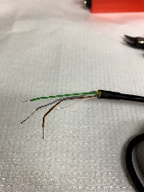 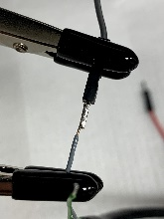 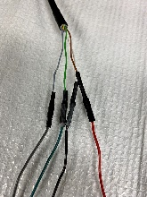

This is how the soldered connection should look

Apply heat shrink to

cover exposed wire for all 4 wires

Isolate additional wires not listed above (red, yellow, blue, and pink)

1. Cut wires near the cable opening leaving ~1cm (A).
2. Cover exposed ends with small diameter heat shrink tubing (B).
3. Bend wires back and use large diameter heat shrink tubing to secure unnecessary wires to the cable (C).

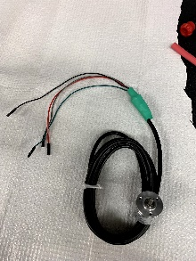

C

B

A

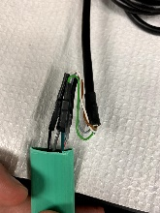

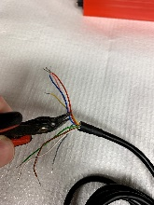

Apply heat shrink to

cover exposed wires

This is what the finished product looks like

### Capacitive Touch Sensor

Components and building materials:

* Electrical component
  + Capacitive touch sensor
* Tools and Materials
  + MM pin array (should be included with capacitive touch sensor)
  + Solder
  + Soldering iron
  + Solderless breadboard

Instructions:

1. Trim the 2 pin arrays to the number of leads on each end of the capacitive touch sensor (MPR121 2022 has 13 pins on one side, and 7 pins on the other).
2. Set the capacitive touch sensor on the solderless breadboard to determine the location of bread board pin receivers that line up with the leads on the sensor.
3. Insert the long end of the pin arrays into the solderless breadboard receivers.
4. Seat the capacitive touch sensor on the short end of the pin arrays. The sensor should rest flush with the top of the plastic component of the pins and the pins should be straight.
5. Apply solder to each of the lead and pin junctions
   1. Place the soldering iron at the junction between the lead and pin.
   2. Apply a small mound of solder to encase the pin making sure that adjacent pins/solder do not make contact.
   3. Repeat for all pins.
6. 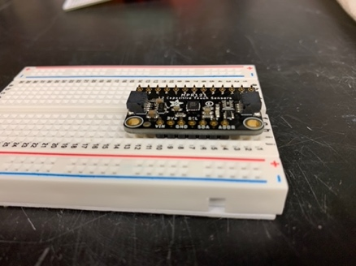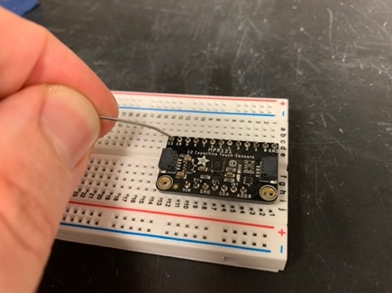Pull the capacitive touch sensor with pins attached off the solderless breadboard.

### Lick detector clip (single spout)

Components and building materials:

* Tools and Materials
  + Jumper cable with a F connector
  + Alligator clips
  + Wire stripper
  + Soldering iron
  + Solder
  + Heat shrink tubing
  + Heat gun

Instructions:

1. Cut and strip the jumper cable leaving ~10mm of wire exposed (total length should be around 15cm).
2. Cut the alligator cable ~20mm from the alligator clip and strip leaving ~10mm of wire exposed.
3. Solder the jumper cable to the alligator clip.
4. Cover the exposed wire with heat shrink tubing.

### Solenoids

Components and building materials:

* Electrical component
  + Solenoids
* Tools and Materials
  + Helping hands
  + Heat gun
  + Soldering iron
  + Solder
  + 2x Jumper wires for each solenoid (preferably 1 color per solenoid)
  + 8x ~2cm small diameter heat shrink tubing (small diameter)

Instructions:

1. Solder the male end of the jumper wires to the exposed wire. Preferably use a unique color for each solenoid (2 red wires for solenoid 1, 2 green for solenoid 2, etc.)
2. Cover the exposed portion of the M pin/wire using small diameter heat shrink tubing.

### Tone Generator

Components and building materials:

* Electrical component
  + Tone Generator
* Tools and Materials
  + Helping hands
  + Heat gun
  + Soldering iron
  + Solder
  + 2x Jumper wires (M to F, or M to M, preferably red and black)
  + 8x ~2cm small diameter heat shrink tubing (small diameter)

Instructions:

1. Solder the male end of the jumper wires to the exposed wire. Preferably keep color consistent (Black to black, red to red).
2. Cover the exposed portion of the M pin/wire using small diameter heat shrink tubing

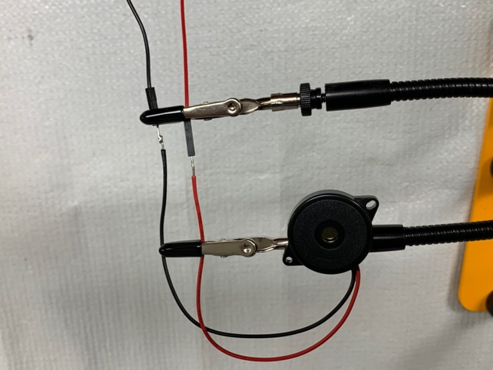

This is how the soldering should look before covering exposed wires with heat shrink

### Arduino Circuit

Components and building materials:

* 3d printed components
  + Arduino case (optional, Arduino circuit can be completed without a case)
* Electrical component
  + Arduino Mega
* Tools and Materials
  + Solderless bread board
  + Wire (Prepared wire or 23 AUG solid)
    - If using 23 AUG solid wire, you will need to cut and strip wire to use with the breadboard.
  + Custom jumper cables (MF)
  + Custom jumper cables (MM)
  + Pin-housing connectors
    - 1x4
    - 1x3
    - 2x8
    - 2x2
    - 1x1
    - 2x6
  + Tip 120 (1/spout)
  + 5.6kohm resistor (1/spout)
  + DC power pigtail (2x)
  + Nylon posts + hex nuts + screws (optional, use with Arduino case) (x2)
  + Wire stripper
  + Soldering iron
  + Solder
  + Heat shrink tubing
  + Heat gun
  + Labels (label maker, tape + sharpie, etc.)

Instructions:

Prepare the Arduino case

1. 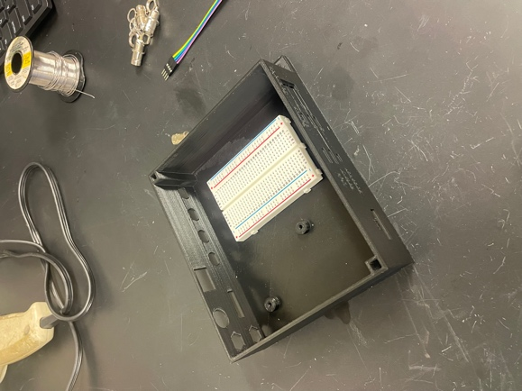Place a solderless bread board in the Arduino box (make sure to leave enough space to the right for the 24V and 5V pigtail wires to fit and enough space to the left for the Arduino Mega)

Solderless breadboard

***Setup Circuits***

Grounding

1. Insert 4 female BNC’s into their holes with the hex screw nuts and metal ground leads
   1. Make sure the golden cups face upwards (will make soldering wires into the cups easier).
2. Tighten the hex nuts to secure the female BNC’s
3. The metal ground leads tend to rotate as well when tightening so make sure the hole remains facing towards the top

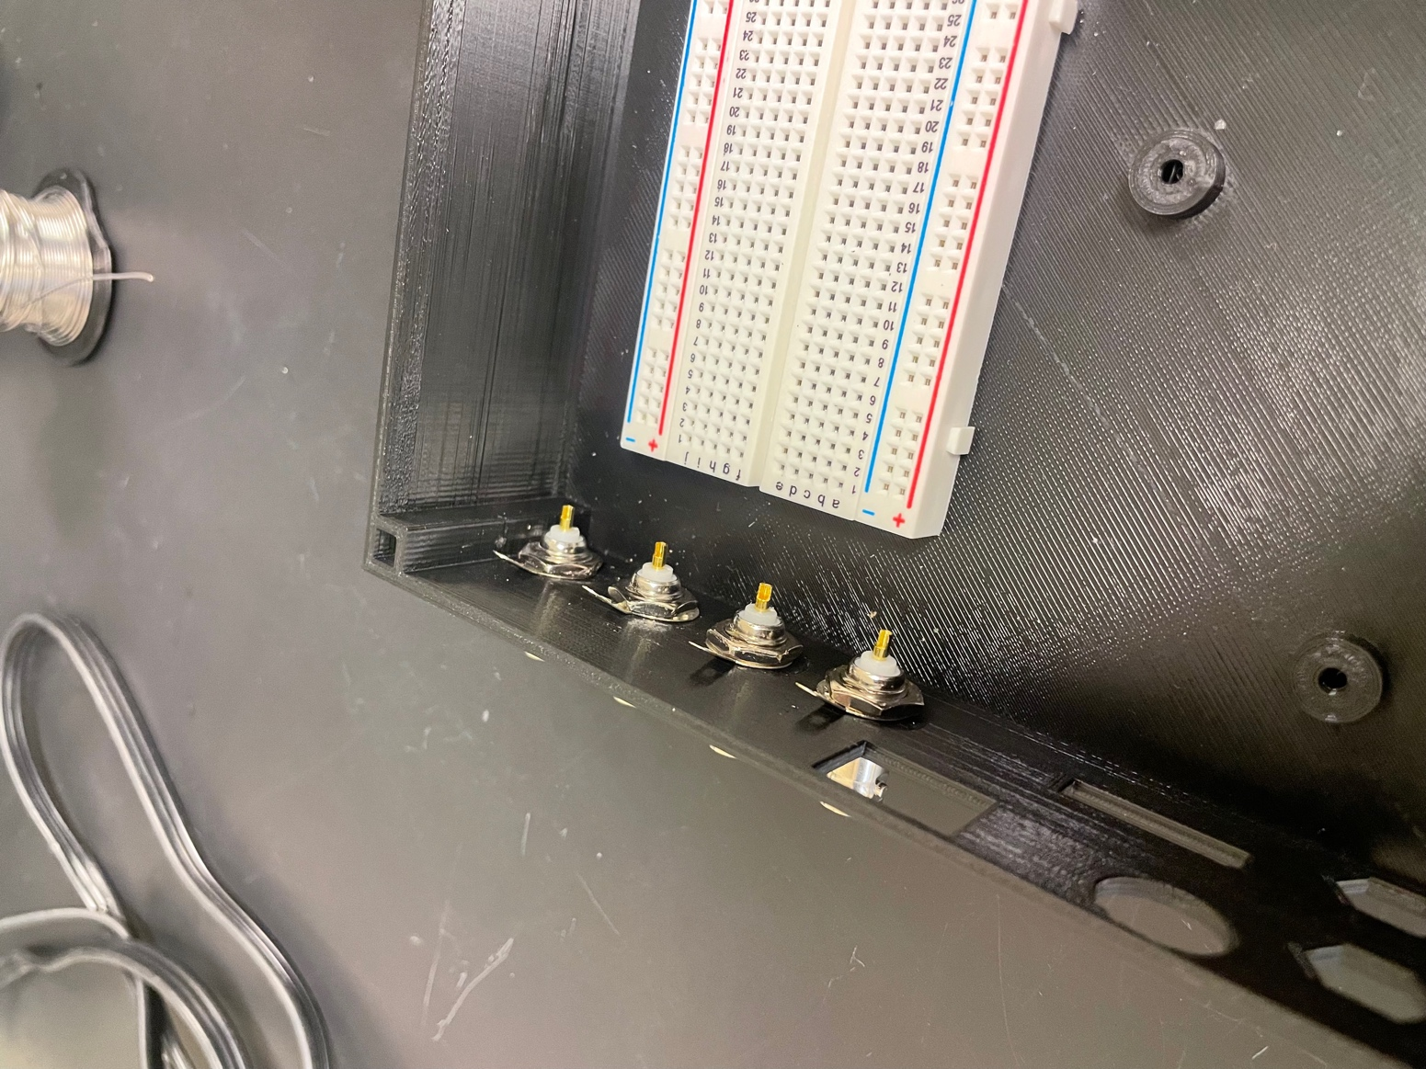

Female BNC’s inserted

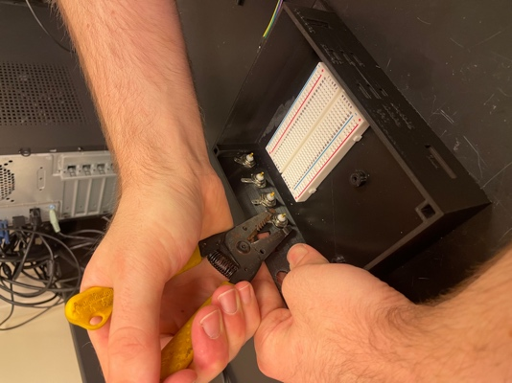

Tighten the hex nuts with plyers

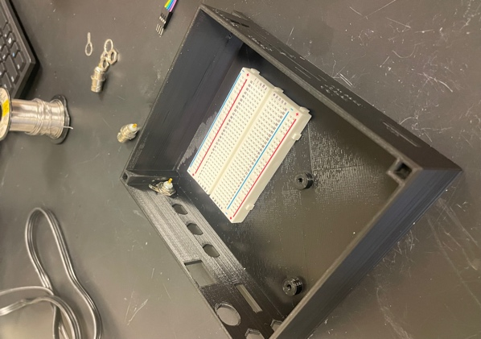

1. Prepare a M/F custom jumper cable and plug both sides into a 1x4 pin-housing connector. Colors do not matter.

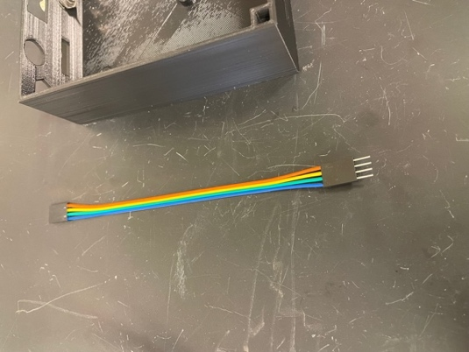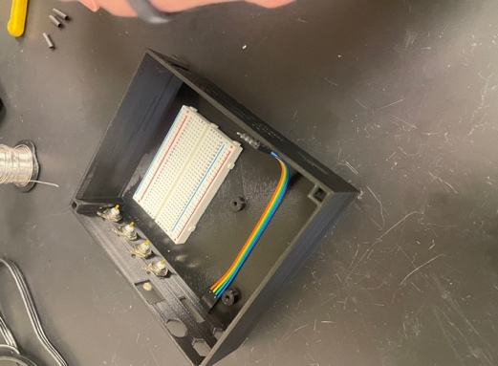

Orientation of wires in box

1. Using prepared wire, cut 4 pieces of differing lengths with the longest being approximately 12.5-13 cm and the shortest being approximately 5-6cm. Then strip both ends of the wires using wire strippers. Need to be long enough to be inserted into the 1x4 female side of the pin-housing connections.

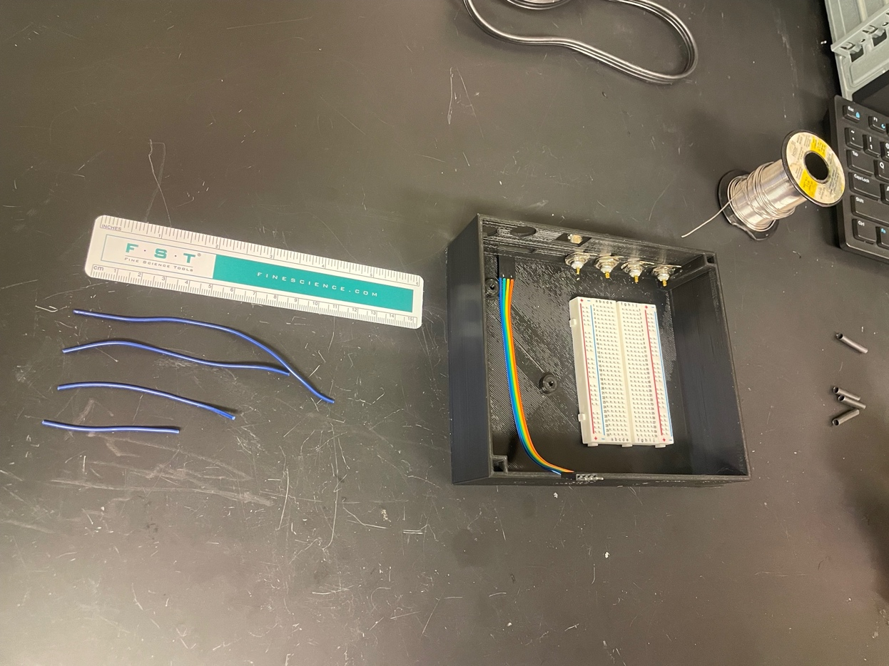

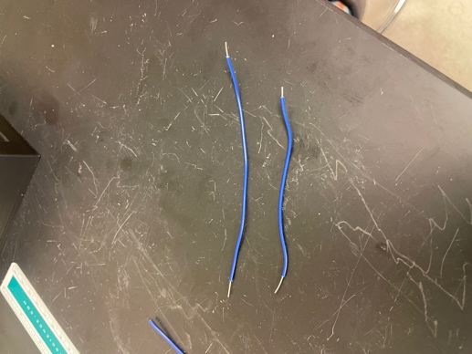

Strip both ends of the 4 wires

Approximate length of the 4 wires

1. Add solder to each of the 4 cups of the BNC
2. Head up the cup using the soldering iron for several seconds, add solder into the cup making sure to melt the solder into the cup and not on the tip of the iron.
3. Recommended to add a heaping amount of solder to make joining the blue wires easier
4. Solder the stripped end of the 4 blue wires to the BNC (be sure the longest wire is the rightmost). Add heat shrink to each of the wires after soldering.
   1. Rest the wire on the solder within the BNC cup, then press a soldering iron against the wire until the wire heats up enough to melt and then sink into the solder.
   2. *Sanity Check:* If you added enough solder, you should be able to press your iron onto the stripped metal and it should slide into the solder in the golden cup in less than 10 seconds. If the solder in the cup is not melting in a few seconds, add more solder and repeat.

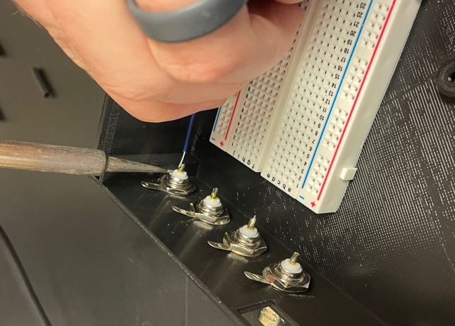

Solder the blue wires to BNCs

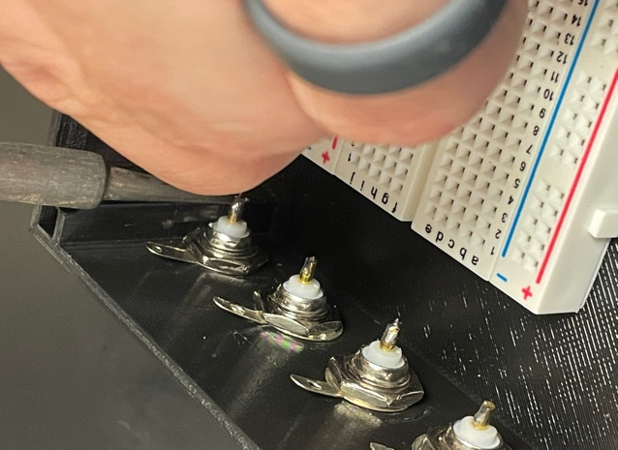

Add solder to the BNC cups

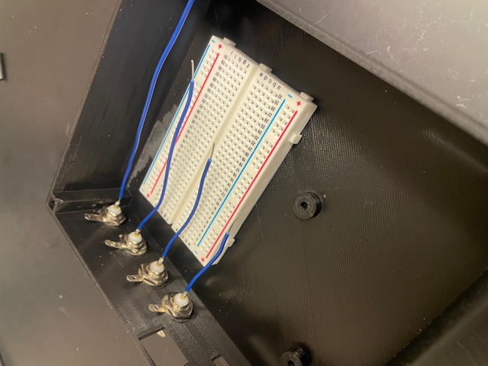

This is how wires should look

Heat shrink

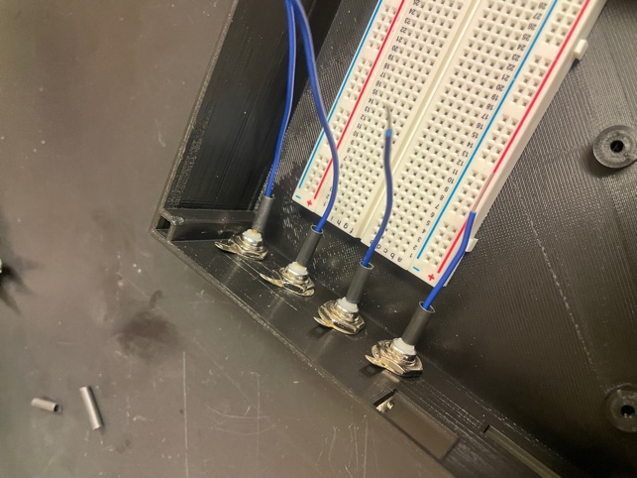

Add heat shrink to the wires

1. Next, we will connect all of the BNC connectors together for grounding. Cut a length of black wire ensuring it is long enough to thread through the ground leads and ground into the breadboard. Strip one end with ~1cm exposed, and the other end with ~10cm (long enough to slide through each of the connectors).
2. Thread the end of the wire with the longer length exposed through the hold of each of the BNC grounding leads, wrapping the end of the wire back around the last lead.
3. Solder each junction between the wire and the BNC grounding leads with enough solder to encase the wire. Check the strength of each soldered point by firmly pulling on the wire.
4. Plug the opposite end of the grounding wire (the side with ~1cm exposed) into the negative column on the solderless breadboard.
5. Next, plug in each of the 4 blue wires into the F 1x4 custom jumper ribbon, making sure to maintain the order of the BNC.
6. Label your breadboard with 5V and 24V

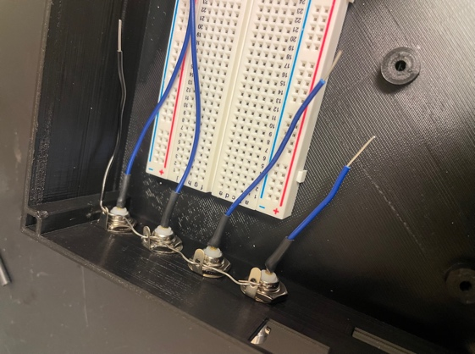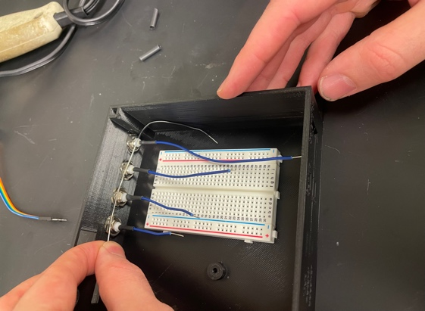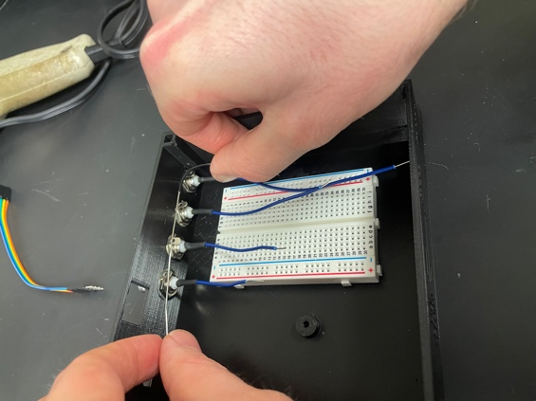

Thread the grounding wire through

the ground leads

About this length for the grounding wire

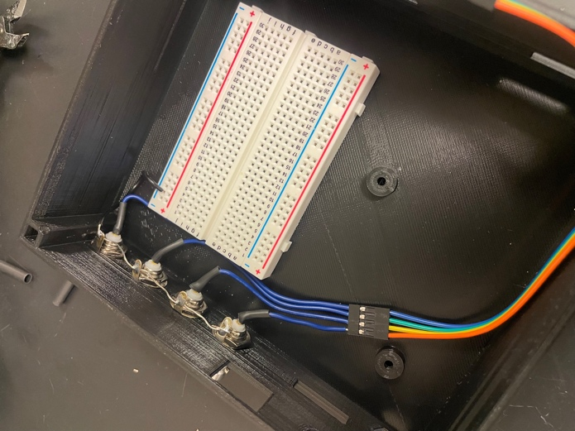

Attach your 1x4 cables to your BNC wires

Power

1. Label the left pair of columns of the solderless breadboard with 5V, and the right pair of columns with 24V.
2. Take the 2 DC power pigtails and strip the red and black wires ~10mm of wire exposed. Firmly twist each exposed wire individually to reduce fraying of the individual strands.
3. Cut 2 lengths of ~3cm of black 23AUG wire, and 2 lengths of ~3cm of 23AUG wire, then strip both ends leaving ~1cm of exposed wire.
4. Add solder to each of the pigtail wires (2 black, 2 red). Use solder to connect each pigtail wire to a corresponding length of 23AUG wire, making sure to keep color coding consistent (red to red, black to black).
5. Slide on a length heat shrink tubing long enough to cover the length of wire exposed at each connection point between the 23AUG wire and the pigtail wire. Heat the heat shrink tubing until it has fully shrunk.
   1. Add on a large diameter length of heat shrink tubing to cover the connection point wires of each pigtail and heat until fully shrunk.
6. Slide connector end of each of the DC power pigtails into hexagonal holes on the upper left side of the box (labeled 24V (top) and 5V (bottom) on the face of the print). Next, plug the 1cm of exposed wire from each pair of pigtails into the corresponding power columns on the solderless breadboard (black wire to the (–) column, red wire to the (+) column). Make sure that the DC power pigtail mounted in the 5V position is connected to the 5V columns, and that the one mounted in the 24V position is connected to the 24V columns.
7. 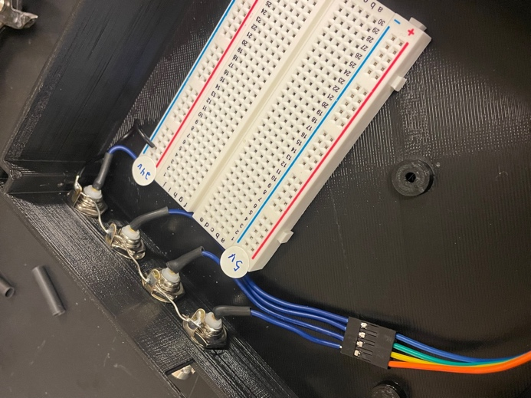Ground the negative columns of each pair of power columns on the solderless breadboard together by cutting a ~7cm length of wire, stripping ~1cm on both sides, and then plugging the wire into both (-) columns. (*Note: you can also use a MM jumper calbe for this*)

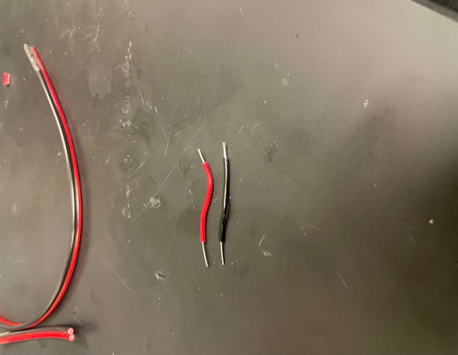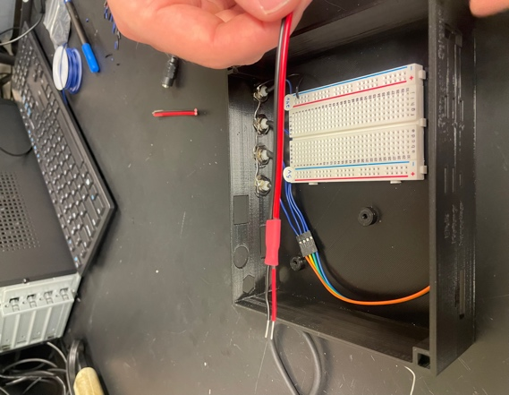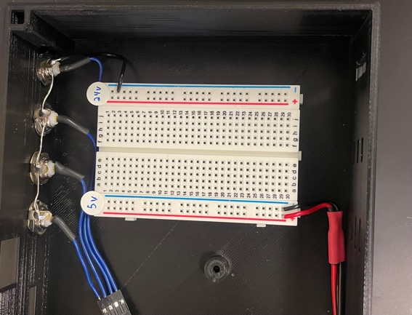

Strip both ends of a black and red wire

Solder wires to pigtails and heat shrink

Plug pigtails into 5V and 24V rails

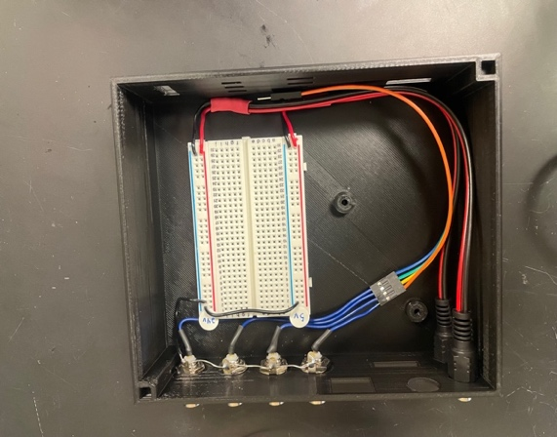

Finished product

TTL *(There are 2 TTL in this box and they are made slightly differently)*

1. For the TTL to the right of the pigtails:
   1. Grab 8 custom M/F jumper cables (black to orange (x2) so you should have 16 wires).
   2. Plug both the male and female pins of those 16 cables into a 2x8 pin-housing connector.
      1. Be sure that the orientation of the colors is identical for both sides of the connector. This means you will need to twist around one set of the the wires when sliding into the pin-housing connector. Black should be across from black etc.
      2. The male pins will be plugged into the Arduino eventually.
2. For the TTL to the left of the lick/rotary/speaker:
   1. Grab 8 custom M/F jumper cables (black to orange (x2) so you should have 16 wires). These will all be below the Mega Arduino.
   2. Plug the female pins of those 16 cables into a 2x8 pin-housing connector and the male pins into a 2x7 pin-housing connector (the black wires should be the ones that are loose).
   3. Put the 2 black remaining male pins into a 1x2 pin-housing connector and both will be plugged into the 5V ground rail.

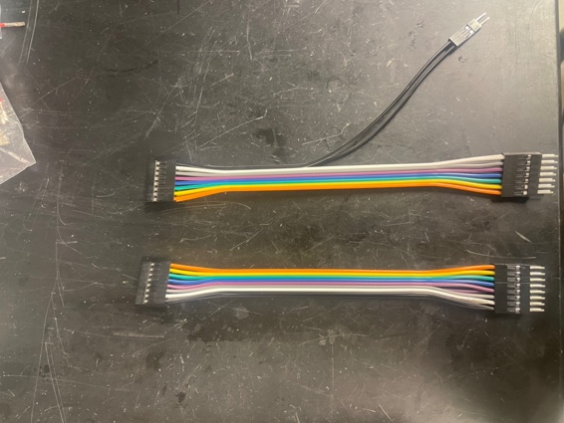

TTL #1

TTL #1 and #2 preparation

TTL #2

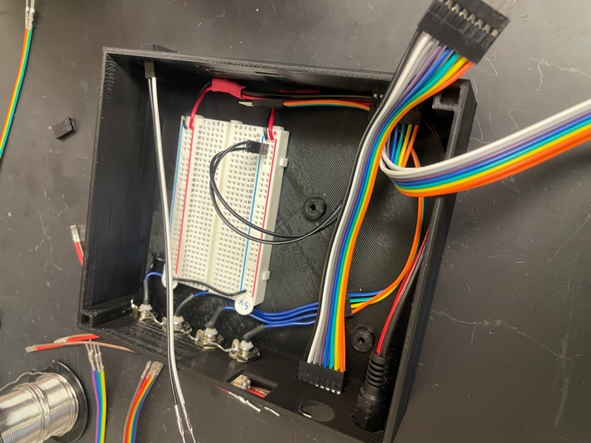

TTL #1

TTL #2

2 black pins

from TTL #2

TTL #1 and #2 assembly

Solenoid

1. Grab 2 custom M/F cables (color doesn’t matter). Plug the female ends into a 1x2 pin-housing connector and each of the male pins into a 1x1 pin-housing connector.
2. Plug both into the 24V rail, but one plugs into the (–) and one plugs into the (+) side.

Servos *(There are 3 servos in this box, and they are made identically)*

1. Grab 3 M/F custom jumper cables (color does not matter). Plug the female pins into a 1x3 pin-housing connector.
2. For the male pins, you will separate the right most pin (orange in the pic below) from the other two (green and yellow). The right most male pins (orange) from all three servos plug in together to a 1x3 pin-housing connector. The two left most pins (green and yellow) will be plugged into a 2x5 pin housing connector.
   1. The yellow wires will go in the left side of the 2x5 and the green wires go in the right side. Once again, colors do not matter, but be consistent and make sure the same color goes on the same side.

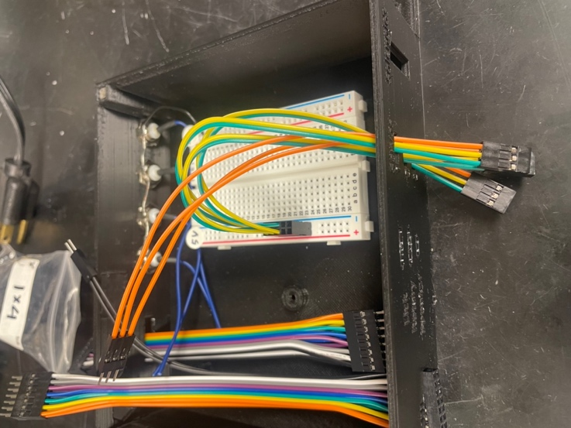

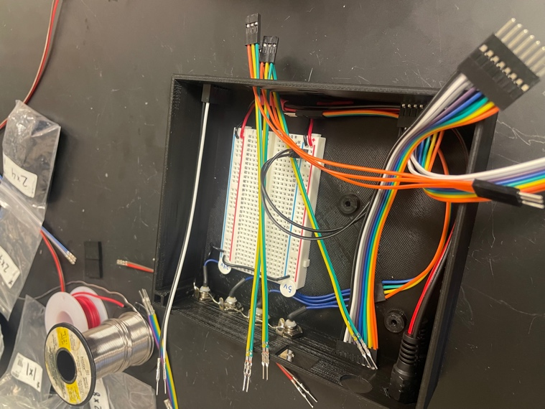

1x3 (x3) for female pins

Rightmost pins (x3) are in 1x3 together

Lick

1. Get 4 custom M/F jumper cables (color does not matter).
2. Plug the female pins into a 1x4 pin-housing connector.
3. For the male pins, divide the 4 wires into 2 groups of 2.
   1. The right two 2 wires will go into the same 2x5 that you plugged the servos into.
   2. Attach a 1x2 pin-housing connector to the left 2 wires. These will be plugged into the Arduino (pins 20-21).

Rotary

1. Get 4 custom M/F jumper cables (color does not matter).
2. Plug the female pins into a 1x4 pin-housing connector.
3. For the male pins, divide the 4 wires into 2 groups of 2.
   1. The right two 2 wires will go into the same 2x5 that you plugged the servos into.
   2. Attach a 1x2 pin-housing connector to the left 2 wires. These will be plugged into the Arduino (pins 2-3).

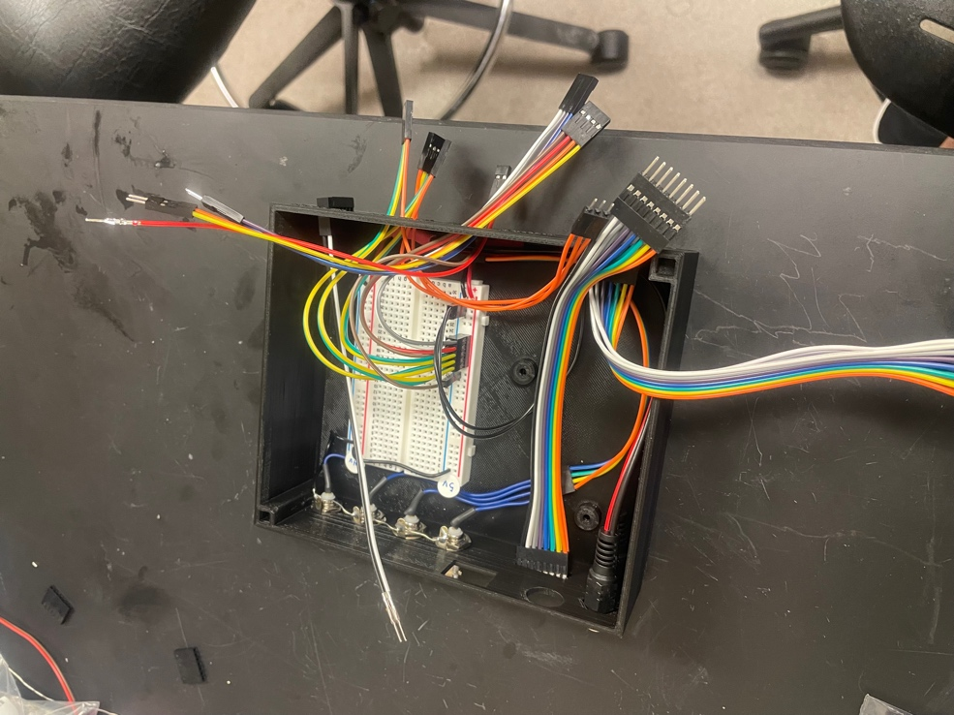

1x4 for rotary/lick

Left 2 wires separated for lick/rotary and each placed in 1x2 connectors

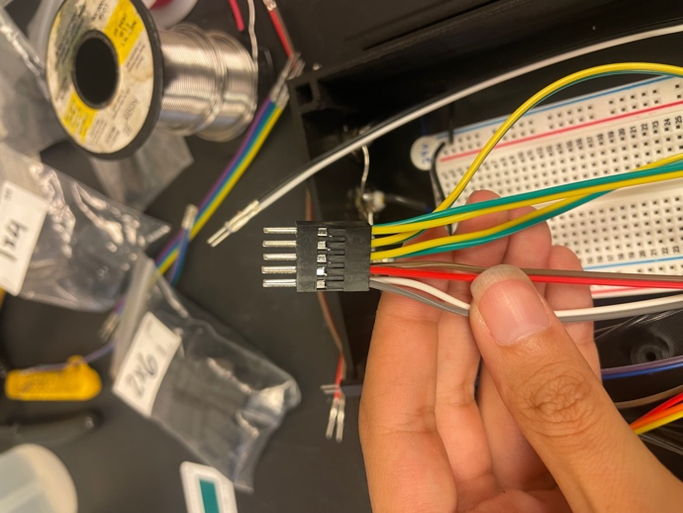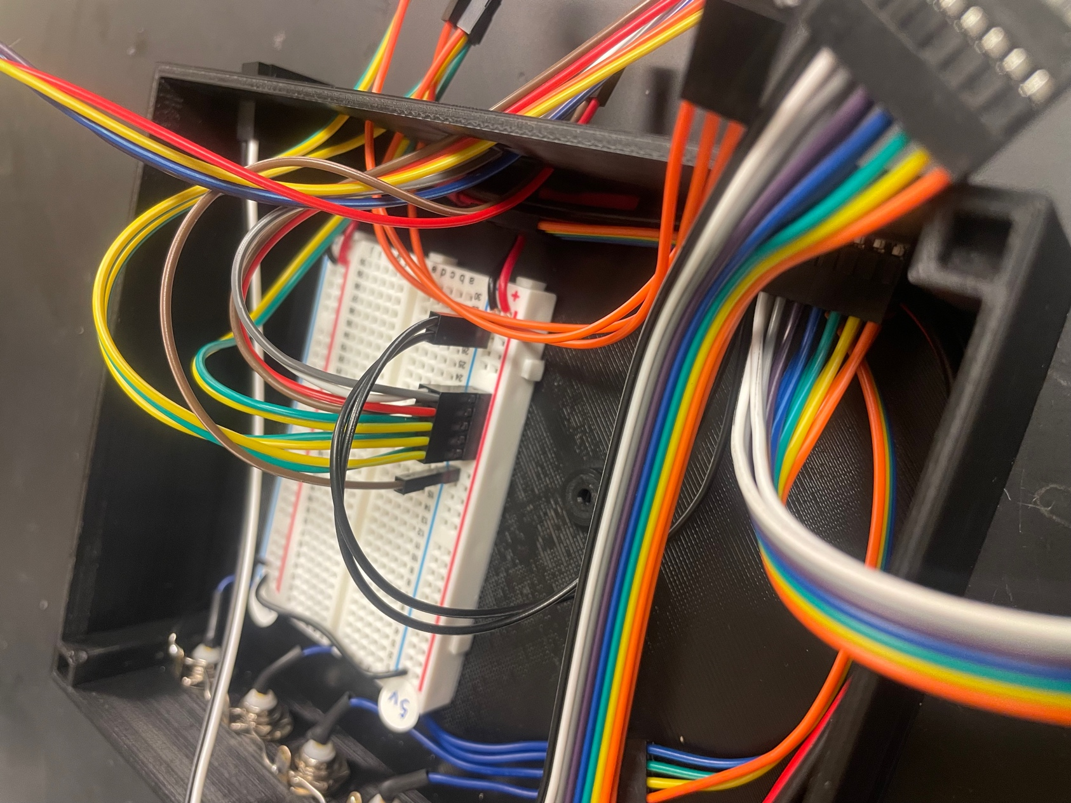

Right 2 wires in 2x5 connector

Speaker

1. Grab 2 custom jumper cables (colors do not matter).
   1. Plug the female pins into a 1x2 pin-housing connector
   2. Each of the male pins gets a 1x1 connector and will be plugged into the Arduino (pin 12).

Insert the Arduino into the box

1. Attach 2 nylon posts to the base of the case by inserting the threaded side of the post through the bottom and rotating the post to screw on hex nuts placed on the bottom.
2. Rest the Arduino on top of the posts and secure in place using nylon screws.
3. Secure the prototyping solderless breadboard by removing the film on the bottom of the board to uncover the adhesive surface. Press breadboard onto the flat surface adjacent to the Arduino.

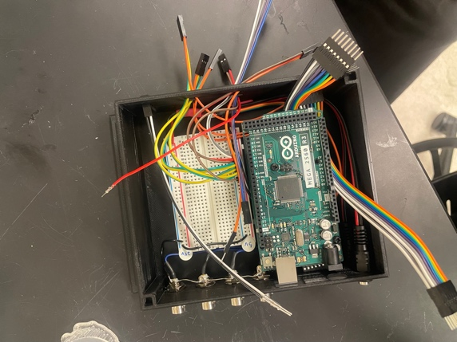

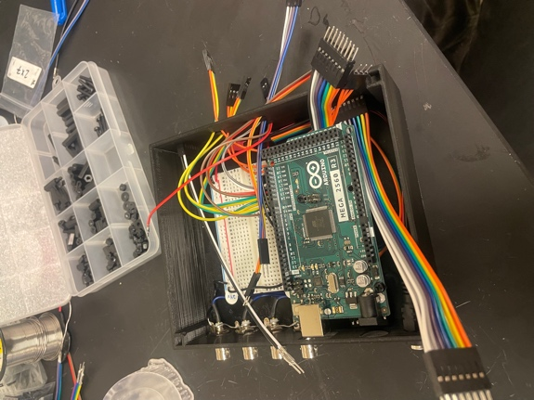

***Arduino Connections***

TTL #1: plug into Arduino pins 40-GND (black wire should be GND)

TTL #2: plug into Arduino pins 26-38 (white wire should be 40)

Lick: plug into Arduino pins 20-21

Rotary: plug into Arduino pins 2-3

Speaker: one pin plugs into Arduino pin 12 and the other into the 5V rail in (-)

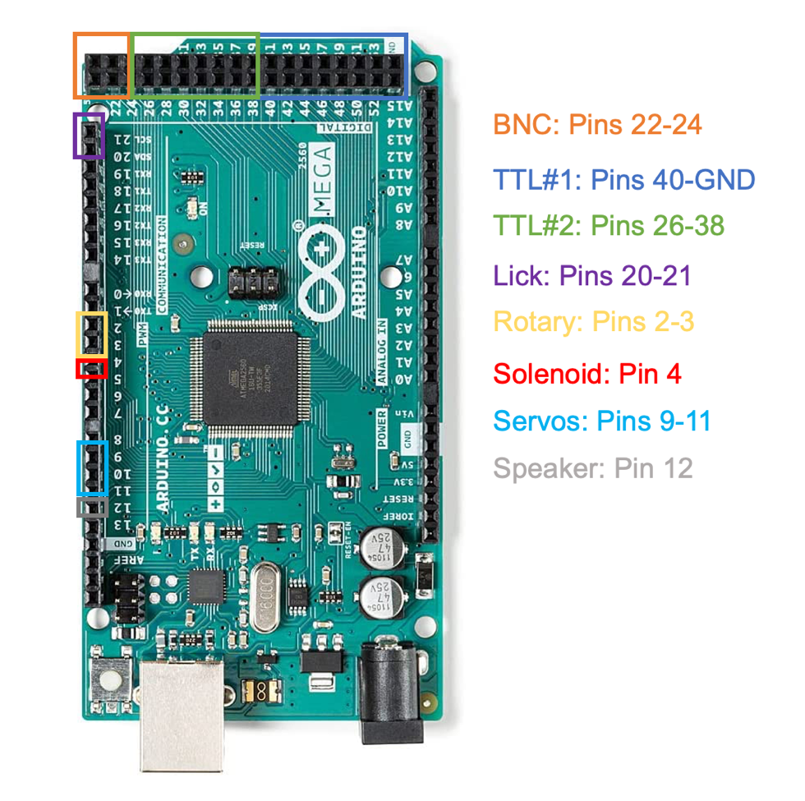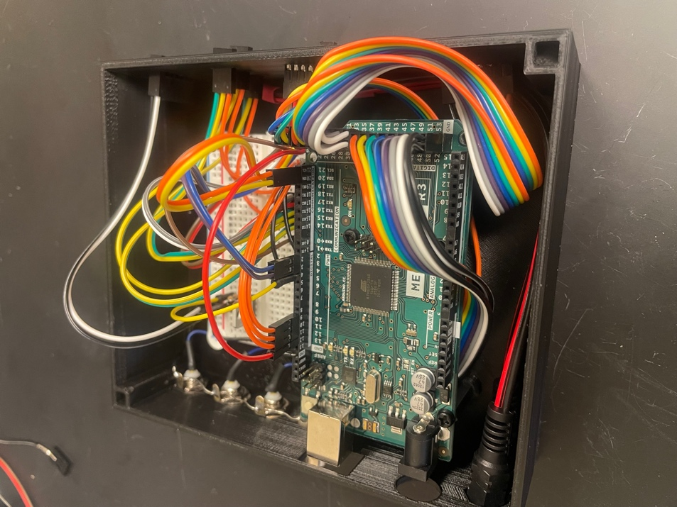Servo: The 1x3 connector with the 3 pins from all 3 servos should plug into Arduino pins 9-12

Ground

* 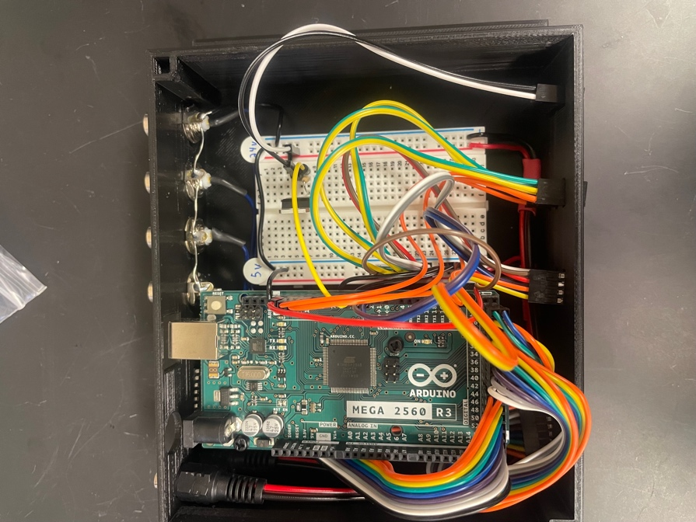Use a jumper cable to connect the ground of one of the rails with a ground on the Arduino.

Black ground cable connected to Arduino

Solenoid circuit

* 1. Attach the transistor with the curved side facing away to a breadboard across 3 columns at the most center position
  2. Interconnect the common ground to the column with the right leg of the transistor
  3. Connect the solenoid to
     1. 24V+ power supply
     2. Column with the left leg of the transistor
  4. Place the resistor into the column with the middle leg of the transistor
  5. Connect an Arduino pin to the column with the resistor and middle leg of the transistor at the most outside position.

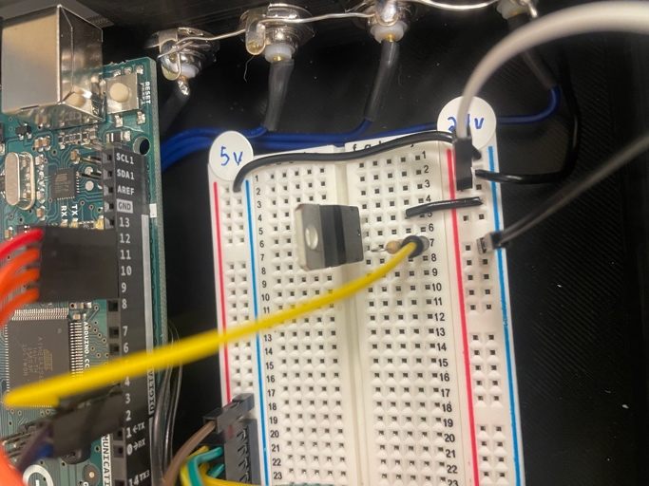

Transistor

Resistor

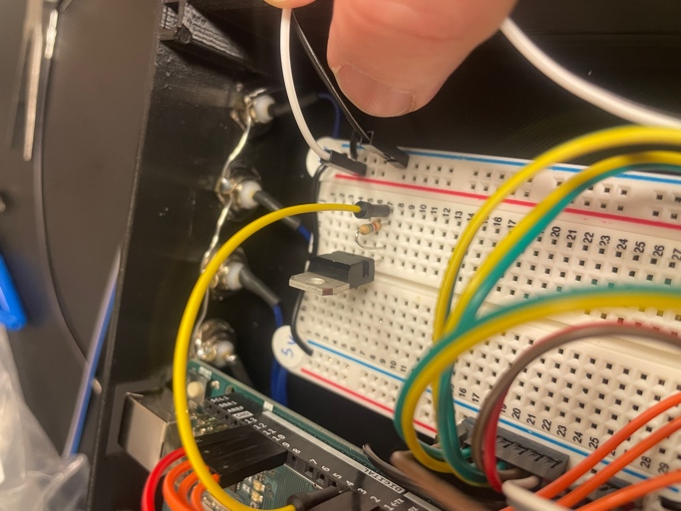

***Final Step of Arduino Assembly***

Epoxy

1. Mix ___ and ____ evenly with cutips to create the epoxy (should look grey). Break the end of a cutip to make spreading the epoxy easier.
2. Spread epoxy over the junctions of the pin-housing connectors meet the box walls and leave overnight to dry.

**Finished Product:**

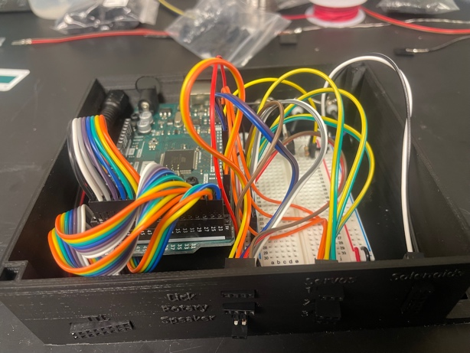

## Final Assembly

### Stage assembly

Components and building materials:

* Pre-assembled components
  + Micro positioner
  + Linear actuator + lick spout (single spout)
  + Linear actuator & radial actuator (multi spout)
  + Wheel break
  + Head-fixation plate
  + Rotary encoder
  + Solenoid (1/spout)
  + Tone generator
* 3d printed components
  + Head-fixation stage*
  + Conical mount*
  + Head-fixation top piece
  + Stage to rotary encoder adapter*
  + Rotary encoder to wheel adapter
* Tools and materials
  + Aluminum breadboard (or metal plate if using magnetic mounts).
  + Lego wheel
  + 2-4x optical posts*
  + 2-4x pedestal post holders*
  + 2-4x clamping fork*
  + M6 screws
  + M6 washers
  + Machine screws (cut to length)
  + Museum putty
  + M3 screws
  + Pointed screws that come with servo horns
  + Phillips screwdriver
  + M6 allen key

Instructions:

1. Set the aluminum breadboard in the middle of your working area.
2. Prepare the head-fixation stage (skip this step if using most-in-one)
   1. Use an M6 screw and M6 washer to attach optical posts to the head-fixation stage. If motion is not a concern, you can get away with using the front 2 positions only.
   2. Attach pedestal post holders to each of the optical posts by using your fingers to tighten the locking screws.
   3. Stand the stage on the aluminum bread board and adjust the position like the photo below, and then loosen the locking screws of the pedestal post holders. Fix the pedestal post holders in place by placing the clamping forks over the base of the pedestal post holders and using an Allen key to drive the screw of the clamping forks into one of the threaded holes of the aluminum breadboard. Use an Allen key to tighten the locking screws of the pedestal post holders.
   4. Attach the Stage to Rotary Encoder Adapter to the head-fixation stage by placing the component in the open portion of the head-fixation stage and sliding backwards as far as the component will go.
   5. Attach Head-Fixation Plate by setting it on top of the front portion of the head-fixation stage with the opening of the Head-Fixation Plate facing towards the center of the stage. There are 4 holes in both pieces that should align. Insert machine screws down through the screw hole and tighten a nut from the bottom until secure.
   6. Attach Conical Mount by first applying a small amount of museum putty to the rear edge of the Head-Fixed Stage. Next, insert the edge of the Head-Fixed Stage into the cut out of the Conical Mount and pressing the Conical Mount forward until the edge has reached the end of the cut out. Firmly press the two parts together using the palms of your hands.

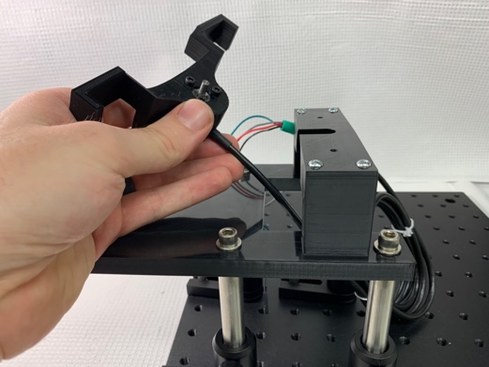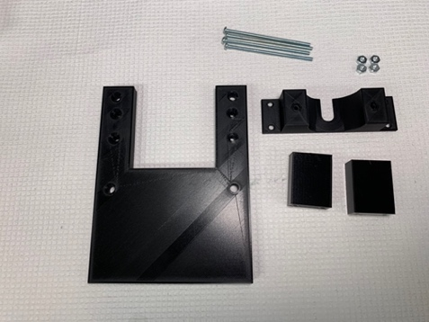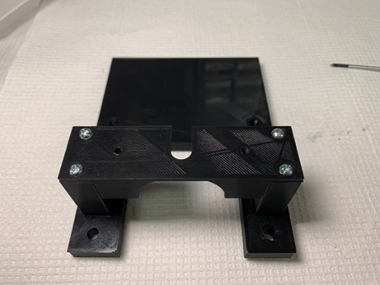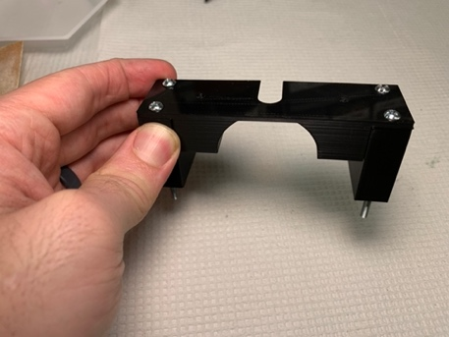

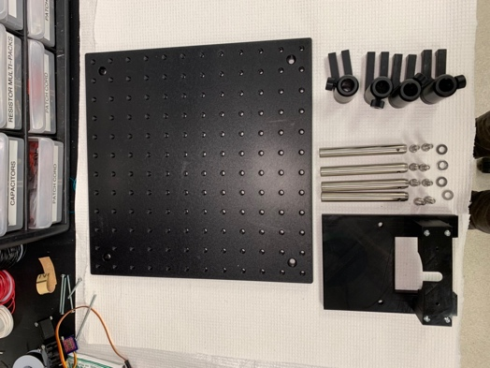

Components for stage assembly

Attach rotary encoder

How head-fixation plate should look

Add locking screws to secure to plate

Components for head-fixation assembly

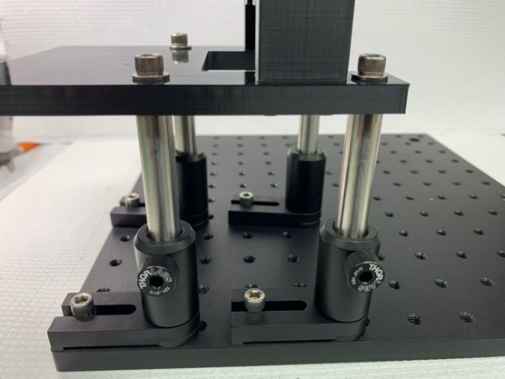

Attach head-fixation plate to aluminum breadboard with pedestal posts

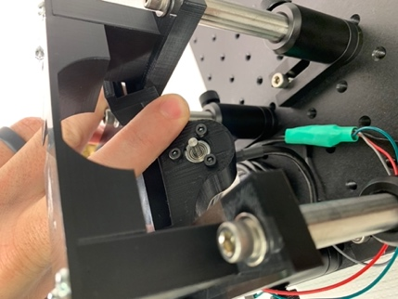

1. Setup wheel and rotary encoder
   1. Slide the rotary encoder into the Stage to Rotary Encoder Adapter. The cable extending from the rotary encoder should be facing down and should slide into the cutout.
   2. Secure the face of the encoder to the front of the Stage to Rotary Encoder Adapter using 3 3m screws.
   3. Attach the Rotary Encoder to Wheel Adapter on the rotating shaft of the rotary encoder. The fit should be very snug: if there is any wobble, switch out the adapter for one with a smaller inner diameter.
   4. Attach the Lego wheel to the Rotary Encoder to Wheel Adapter by carefully pressing the wheel on.
2. Setup the wheel break and tone generator
   1. Lift the break bar to rotate the servo counterclockwise so the bar is as vertical as possible
   2. First clip the wheel break onto the posts by first connecting the side with 1 clip onto the right side of the stage (while looking towards the stage from the front), and then clip the
   3. Secure the tone generator to the front of the break mount using 2 screws passing through the holes in the tone generator and into the holes in the break mount
3. Setup the Micro Positioner and single spout or multi-spout
   1. Attach the cover of the linear actuator to the Z-adapter on the Micro Positioner by holding a hex nut in the hex inset within the rear side of the Z-adapter and then screwing a screw in place using a Philips head screwdriver. Repeat for the second screw.
   2. Place the Micro Positioner / Spout Assembly in front of the Head-Fixed Stage such that the spout is perpendicular to the Head-Fixed Stage
   3. Secure the Micro Positioner base to the aluminum bread board using an M6 screw and M6 washer.
4. Move stage and Arduino Case into the behavioral box adjacent to one another

### Connecting electrical components

Components and building materials

* Pre-assembled components:
  + Assembled Head-Fixation Stage
  + Assembled Arduino circuit
* Tools and materials
  + Jumper cables (MF)
  + Wire (solid 23AUG)
  + Wire stripper
  + 5V power adapter
  + 24V power adapter
  + Zip ties
  + Labels (label maker or tape + Sharpe)

In this section we will hook up all the electronic components to the Arduino circuit we assembled previously. The wires from the components will need to be extended by attaching additional jumper cables, or by cutting and stripping solid 23AUG wire.

1. Solenoids
   1. First determine roughly where the solenoids will be located on the exterior of the box. Eventually, the solenoids will be mounted to the 3d printed Solenoid Mount on the outside wall of the behavioral box or on an adjacent wall (see overview images for an example).
   2. With the position of the solenoids in mind, measure out the length of wire necessary to extend the wire of the solenoids to the Arduino Circuit.
   3. Cut and strip all the necessary wires (2 / solenoid) leaving ~10mm of wire exposed.
   4. Solder one end of each wire to the wire of the solenoids
   5. Wrap an adhesive label around each pair of wires that correspond to a unique solenoid.
   6. Attach solenoid wires to Arduino Circuit
      1. If using the prototype version of the Arduino Circuit, plug the free end of the wire into the solenoid circuit in the position shown here
      2. If using the perma proto version of the Arduino Circuit, attach the free end of the wire to a FF jumper cable and then attach the other end of the jumper cable into the appropriate pin.
   7. Zip tie solenoid wires together to help stay organized
2. Servos
   1. Attach jumper cables to the servo cable (MM for the prototype version, MF for the perma-proto version)
      1. 5V Power (Orange) -> Red
      2. Ground (Brown) -> Black
      3. Signal (Yellow) -> Yellow
   2. Attach servo wires to Arduino Circuit
      1. If using the prototype version of the Arduino Circuit
         1. Plug the red wires into the positive row of the 5V rail on the solderless breadboard.
         2. Plug the black wires into the common ground
         3. Plug the yellow wires into the Arduino pins [][][]
      2. If using the perma-proto version of the Arduino Circuit, attach the female jumper cables to the corresponding pins on the outside of the Arduino case
3. Tone generator
   1. Attach jumper cables to the tone generator wires (MM for the prototype version, MF for the perma-proto version) to the red and black wires
   2. Attach tone generator wires to Arduino Circuit
      1. If using the prototype version of the Arduino Circuit
         1. Plug the red wire into Arduino pin []
         2. Plug the black wire into the common ground
      2. If using the perma-proto version of the Arduino Circuit, attach the female jumper cables to the corresponding pins on the outside of the Arduino case
4. Rotary encoder
   1. Rotary encoder jumper cables to the Arduino Circuit
      1. If using the prototype version of the Arduino Circuit
         1. Plug the red wire into the positive row of the 5V rail on the solderless breadboard
         2. Plug the black wires into the common ground
         3. Plug the wire for Rotary Encoder A (grey) into Arduino pin 2
         4. Plug the wire for Rotary Encoder B (green) into Arduino pin 3
      2. If using the perma-proto version of the Arduino Circuit, attach the female jumper cables to the corresponding pins on the outside of the Arduino
   2. Roll up and zip tie unnecessary cable.
5. Lick Detection
   1. Measure the distance from the top of the Linear Actuator to the Arduino Circuit using a piece of wire
   2. Cut 4 wires to match the length that you measured
   3. Cut and strip 2 jumper cables to provide you with F and M connectors
      1. Cut 2x MF for the prototype version
      2. Cut 2x FF for the perma-proto version
   4. Solder the exposed wire of the jumper cables to the wire you cut in step b so one side has a F connector and the other has either a M or F connector.
   5. Connect the Capacitive Touch Sensor to the Arduino Circuit
      1. If using the prototype version of the Arduino Circuit
         1. Connect the VIN pin to the positive row of the 5V rail
         2. Connect the GRD pin to common ground
         3. Connect the SDA pin to Arduino pin 20
         4. Connect the SCL pin to Arduino pin 21
      2. If using the perma-proto version of the Arduino Circuit, attach the female jumper cables to the corresponding pins on the outside of the Arduino
   6. Zip tie the pins / connectors onto the top of the linear actuator to fix the cap sensor in place
   7. For the Single spout version
      1. Attach alligator end of the Lick Detector Clip to the metal lick spout and the F connector end to the Capacitive Touch Sensor Pin 1
   8. For the multi spout version
      1. Plug spouts 1-5 into Capacitive Touch Sensor pins 1-5
6. Power
   1. Plug the 5V and 24V power adapters into a power strip
   2. Clearly label the adapter and DC ends of each power adapter with the corresponding voltage
   3. Plug the DC end into the corresponding DC pig tail.

### Liquid delivery

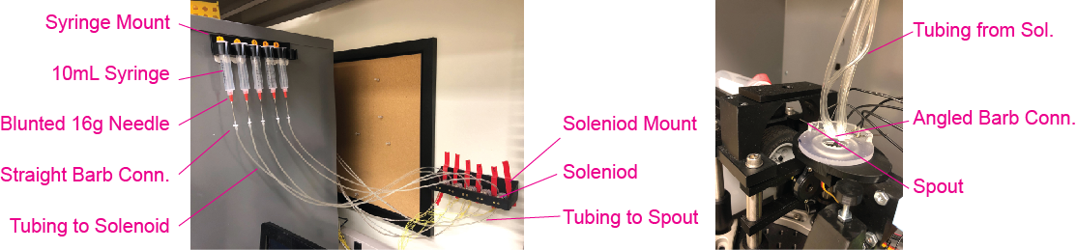

1. Fix the syringe mount and solenoid mount onto the side of the box or a wall nearby using 4 1” command strips. Different behavioral boxes produce varying levels of noise when the solenoid opens. If you choose to mount the solenoids directly to the box, make sure to test the noise level produced during solenoid operation.
2. For each syringe, dull a 16-gauge needle using a dremel and connect it to the syringe. Next, press the straight barb connector onto the 16-guage needle forcefully until secure.
3. Cut 2 sets of tubing that connects 1: the syringe to solenoid, and 2: the solenoid to each spout. You will need 1 set of tubing for each spout. Make sure the length of tubing within each set is consistent. Stretch each end of the tubing so it can stably couple with a straight barb connector on one side and the solenoid on the other side. To stretch the tubing, use a pair of hemostats or plyers and forcefully insert into the end of the plastic tubing and then open the tool until the tubing begins to go opaque. Repeat this step until the tubing on each side is wide enough to securely fit onto the corresponding connector.
4. Couple the first set of tubing to the barb connector attached to the syringe and the barb connector on the solenoid, couple the second set of tubing to the barb connector on the solenoid and the straight or elbow connector on the spout.
5. Check to ensure there is smooth flow through each of the lines
   1. Fill a syringe with ~10 mL DI water
   2. Open the solenoid using the Arduino script “touch_to_open”
   3. Place the spout into a container or hold a container directly under / in front of the spout.
   4. Push a 10mL plunger into the syringe and continue to depress until liquid flows freely through the spout
   5. TROUBLE SHOOTING: If you notice that an excessive amount of force is necessary for flow, then replace the straight barb connector on the syringe and try again. If this fix does not work, then check to see if the solenoid or spouts are clogged.